Templates
These are some templates that were presented in the textbook Requirements Analysis, Tradeoff Studies and Risk Analysis, authored by Terry Bahill and Azad Madni and published by Springer, 2016.

A use case template
A use case is an abstraction of required functions of a system. A use case produces an observable result of value to the user. Each use case describes a sequence of interactions between one or more actors and the system. Our design process is use case based.
Name: A use case should be named with a verb phrase in active present tense form. It should not relate to any particular solution.
Iteration: This is configuration management. Sometimes we just number them.
Derived from: Explain the source for the use case, for example the mission statement, concept of operations, business use case or customer requirement.
Brief description: Describe the general sequence that produces an observable result of value to the user.
Level: The amount of detail required in the use case. Do not mix classes of different levels in the same use case.
Priority: The importance of this use case relative to other use cases.
Scope: This defines the boundary of what the use case applies to.
Added value: Describe the benefit (usually) for the primary actor. This is an important slot.
Goal: The goal is the behavior that the primary actor expects to get from the use case. You should have a goal or an added value, but probably not both.
Primary actor: Actors are named with nouns or noun phrases. Actors reflect roles of things outside the system that interact with the system. Primary actors initiate the functions described by use cases.
Supporting actor: Supporting (or secondary) actors are used by the system. They are not a part of the system, and thus cannot be designed or altered. They often represent external systems or commercial-off-the-shelf (COTS) components. If your system affects them, then those effects are unintended consequences.
Frequency: How often is the use case likely to be used? When this slot is helpful, it is very helpful. When it is not, do not use it.
Precondition: The precondition (and the postcondition) should contain, among other things, the state of the system and values for pertinent attributes before the main success scenario starts.
Trigger: The trigger should contain the event that causes a transition from the precondition state to the first step in the Main Success Scenario.
Main Success Scenario:
1. The numbered set of steps that illustrates the usual, successful interactions of actors with the system. Usually the first step states the action of the primary actor that starts the use case.
2a. The last step tells you where to go next, for example [exit use case].
Alternate Flows:
2b. Alternate flows describe failure conditions and unsuccessful interactions [exit use case].
Postcondition: Describes the state of the system after exit of use case no matter which flows were executed. This is hard to write.
Specific Requirements
The steps in the main success scenario should suggest the functions that the system is supposed to perform. From these we should be able to write system requirements.
Functional Requirements: Describe the functional requirements with shall statements.
Nonfunctional Requirements: Describe the nonfunctional (often performance) requirements with shall statements.
Author/owner: This is an important field.
Last changed: Use some form of configuration management such as the date of the last change or the revision history.
No standard specifies which slots should be in a use-case description. Your minimal set should be based on your company requirements’ template. The number of slots and the detail in each slot increases as the design progress from the requirements model to the analysis model to the design model to the implementation model. Other useful slots contain Priority, Rules, Assumptions and Extension Points. Do not use slots that do not help you. If you find that the Trigger, Precondition and Postcondition do not help you to create state machine diagrams, then do not use them. A use case description is also called a use case report and a use case narrative. A use case package contains a use case description, sequence diagrams, supplementary requirements and other UML stuff.

Evaluation Criteria Template
Evaluation criteria are used to help select amongst alternatives in tradeoff studies, quantify requirement satisfaction and assess performance of the system. Criteria should be created with the intent of reuse. To this end, a company should have a library of generic criteria.
Name of criterion: Criterion names should be short, but should not be abbreviations.
Description: This is an expansion of the criterion name. It explains what the criterion is supposed to assess. It should describe how this criterion will determine how well the alternative, requirement or system satisfies an attribute.
Weight of importance: This is usually a number between 0 and 10 (or maybe between 0 and 1) that states how important this criterion is compared to other criteria. Weights of importance will be derived in discussions with stakeholders.
Basic measure: The basic measure is the value of what will be measured or calculated. A measure indicates the degree to which an entity possesses and exhibits a quality or an attribute. The basic measure’s name is often similar to the name of the criterion.
Measurement method: This describes the method that will be used to measure and/or calculate the basic measure. This will vary with the phase in the system life cycle.
Units: SI units are preferred, except when interfacing with a human. For example, when communicating with a human, we use baseball units: miles per hour, inches, feet and ounces. However, inside the system, all calculations are done with SI units.
Scoring function inputs: This contains the domain of definition (legal values) and expected values.
Scoring function type and parameters: Specify the scoring function and its parameters.
Scoring function output: This will probably be 0 to 1. More output should be better than less output.
Properties: Is this evaluation criterion quantitative, objective and worded correctly? What other criteria might this criterion depend on or be dependent on? What other criteria might this criterion be traded off with (exhibit compensation with)?
Trace to a function, a tradeoff requirement, the concept of operations or a customer statement.
Owner is responsible for creating and maintaining and approving changes to this evaluation criterion.
Date of last change: or some other configuration management date

Technical Performance Measure Template
Name of TPM:
Purpose of TPM: i.e. how will it be used?
Source requirement: a TPM must be tied to a requirement (or a WBS element)
Type of the source requirement: I=contract req., II=derived req., III=goal in contract, IV=required by reference
Risk level: resolve, manage, monitor or accept
What should be measured? include units of measurement
How should it be measured? inspection, modeling, simulation, analysis, test, software scripts
How often should it be measured? this could be time-based or tied to milestones
During which phase of the project should it be measured? when do you stop collecting data?
How should it be displayed? a figure may be best
To whom should it be presented?
Thresholds above or below which action is necessary: these may be on the figure
What action should be performed if thresholds are exceeded?
Who should perform this action?

A requirement template
Table 27.1 A requirement template
Attribute | Explanation
Identification tag (Id) | The ID tag should reflect the tree structure of the requirements database. It is usually numeric.
Name | This should be short, but not be an abbreviation.
Text | This must be worded carefully paying strict attention to all the characteristics of good requirements explained in Chapter 27.
Priority | This gives the importance of the requirement with respect to all other requirements in the database. It is often a number between 0 and 10.
Verification method | Explain how this requirement will be verified during each phase of the system life cycle. Typical verification methods include inspection, analysis, test and demonstration.
Computed cost | Computing the cost to satisfy a requirement will cost time and money, so it should only be computed for high priority requirements.
Difficulty | Estimate how difficult it will be to satisfy this requirement
Link to TPM? | If it is linked to a technical performance measure, specify the linkage.
Derive Reqt: | Indicate the parent requirement and possibly children.
Owner | A requirement’s owner communicates with the customer, defines and tracks trade-offs of the requirement with other requirements and approves changes in the requirement.
Date of last change | This is needed for configuration control.
Comment | Comments may explain any of the template fields.
Other fields (attributes) that might be in the database include functional area, type of requirement (mandatory or tradeoff), source of requirement (engineering, marketing, reliability, safety, security), stability, assigned to, status, due by date and allocation

A Tradeoff study template
Download BIMStextbook.xlsx from www.Springer.com/ISBN or from http://www2.engr.arizona.edu/~sysengr/forStudents/index.html.

A risk template
These are the attributes for our risk template. They will be the column headings in the risk template spreadsheet.
Potential failure event that will have a negative impact on the project or the people.
Consequences or potential effects describe what this negative impact might be if the risk is not mitigated or managed, for example, project delay, expenditure to date wasted, reduced performance or reduced product quality. Once analyzed, risks should be evaluated to determine the likelihood of a risk or threat being realized and the seriousness, or impact, should the risk occur.
Frequency of occurrence (or relative likelihood) of the event occurring can be derived from historical data or it can be estimated based on expert opinion.
Severity of consequences is a measure of negative impact or overall loss of value from a project if the threat emerges. Severity of consequences of a potential failure event can be based on historical data or expert opinion.
Estimated risk is usually defined as the product of relative likelihood and severity of consequences.
Priority: Use numeric values for estimated risk as well as criticality to mission success, customer satisfaction, effect on architecture, business value to prioritize the risks.
Mitigation method: What we are already doing about it.
Countermeasures: Actions to be taken to prevent, reduce, or transfer the risk. This may include production of contingency plans.
Trace to: Most risks can be traced to requirements or brain storming sessions.
Status: Indicates whether this is a current risk or if risk can no longer arise and impact the project. Example classifications are active, inactive and resolved.
Assigned to: This is the person or team that is responsible for tracking the risk, reporting the risk and ensuing that proper mitigation of the risk is performed.
Dates: date that the risk was identified, modified, or targeted for resolution.

Table 35.1 Selected risks for incorporating solar PV subsystems into a commercial electric grid.
Potential Failure Event | Consequences or potential effects | Frequency of Occurrence | Severity of Consequences | Estimated Risk, defined as frequency times severity | Identification Tag | Assigned to
Solar panel output drops by 60 MW in a 15-minute interval. | Breakers could trip leaving customers without electric power. Voltage on the grid could drop. | 95 | 200 | 19,000 | A | Bill
Feeder circuit disconnects from substation | Feeder circuit voltage could get out of phase with the grid. | 330 | 1 | 330 | B | Terry
Where did the data come from? On what date were they accepted?
Each row in a risk table describes particular risk. It contains a potential failure event, the consequences of that failure event, the frequency of occurrence (or relative likelihood) of the event, the severity of consequences, the estimated risk, a short identification tag and the person who is responsible for the risk.
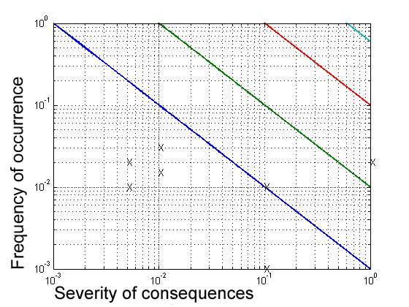
Fig. 32.2b Log-log plot of xy= 0.001, xy= 0.01, xy=0.1 and xy=0.6,
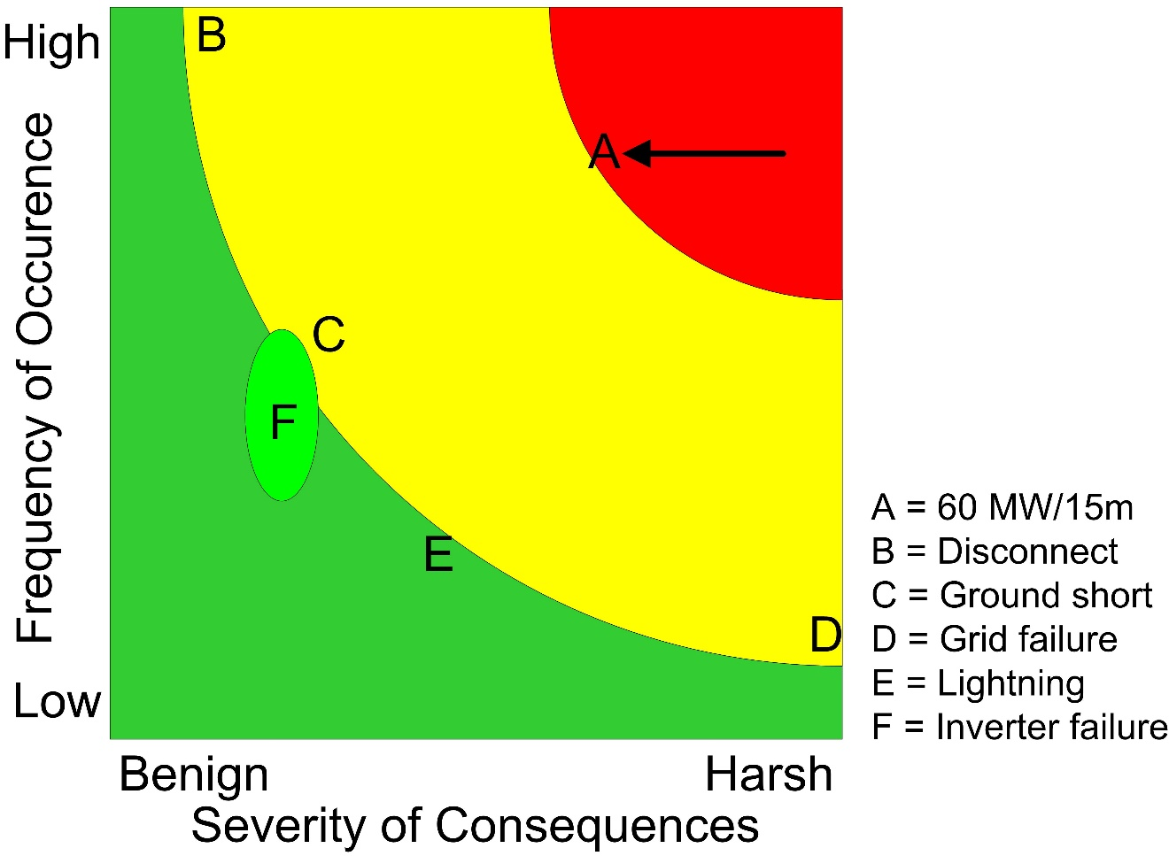
Fig. 33.1 A linear risk chart.

