Scoring Function Toolbox
User Operation Guide
by
Edwin Ordoukhanian
ordoukha@usc.edu
for use with

Trade-off Decisions in System Design
- Terry Bahill and Azad M. Madni

Spring 2016
Contents
1. Installing Tool for the First Time 2
2. Interface Overview 9
2.1. Scoring Function List 9
2.2. Variable Input Panel 9
2.3. Graph Type Panel 9
2.4. Export Panel 10
2.5. Score calculator 10
3. Illustrative Example 10
3.1. Selecting desired scoring function 10
3.2. Inputting variables for a SSF 11
3.3. Choosing Graph Axes Type and Ratio 12
3.4. Plotting and Dealing with Errors 16
3.5. Exporting to a Figure 19
3.5.1. Saving the Plot 21
3.5.2. Looking at the Data Points 22
3.6. Exporting Data to Excel File 24
3.7. Calculating Individual Scores 27

Installing Tool for the First Time

Installing the program for the first time might take longer than in routine use. In order to run the software, MATLAB’s Compiler Runtime (MCR) has to be installed on the user’s computer. The process is straightforward.
By double clicking on “SSFtool_pkg” (see Fig 1) a command prompt screen will appear on the screen (See Fig 2). The software will automatically decompress its content and save the files in the same directory (folder) (See Fig 3). Depending upon what programs and folders are already installed on your computer, you may or may not see the following screens. For example, upon decompression, if user’s computer does not have .NET Framework, the installer will guide the user to download and install .NET framework (see Figures 4, 5 and 6).
Note: If you are running the software for the second time, you do not need to follow the above instructions. Just double click on “SSFtool.exe” and run the toolbox.
Note: “SSFtool.exe” is standalone exe file. It does not have to be in the same directory as “SSFtools_pkg” or in any other particular directory..
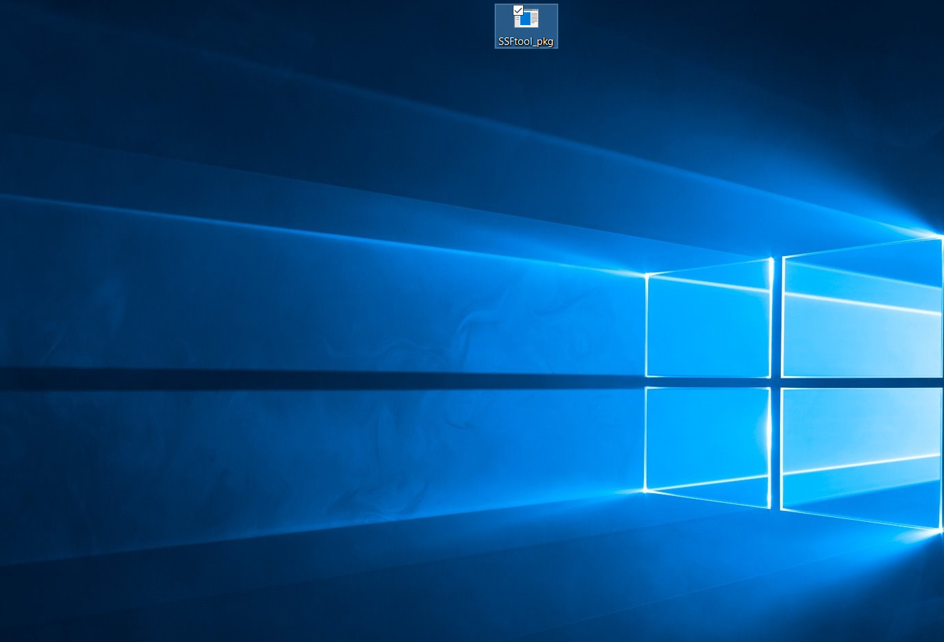
Fig 1. Running “SSFtool_pkg”

Fig 2. Command Prompt Screen
The user account control may ask your permission to allow this program to make changes to your computer.
Fig 3. Extracting MATLAB Complier Runtime
When it is done move the WinZip self extractor box off of the middle of the screen. It may ask you to accept the license agreement. If .NET Framework is not already on our computer, then you may see a screen like this
Fig 4. Downloading and installing .Net Framework
Fig 5. Downloading and installing .Net Framework
Fig 6. Downloading and installing .Net Framework
Once .Net Framework is installed, the software will continue its installation process (see Fig 7). By clicking “Next,” the installer will ask for the directory where MATLAB’s Complier Runtime will be installed (see Fig 8). Since the directory does not exist on the machine, a window will pop up and ask to confirm that the user would like to create the directory. By clicking “Yes” (see Fig 9) the directory will be created and the installation process will continue.
Fig 7. MATLAB Complier Runtime Installer
Fig 8. Creating Directory to install MATLAB Compiler Runtime
Fig 9. Confirming Directory to install MATLAB Compiler Runtime
You may not see this screen depending on what is already on our computer.

On the next screen, the installer will ask to confirm that the user is willing to install MATLAB Complier Runtime (see Fig 10). By clicking “Install,” the installation process will continue and once it is done, the user clicks on “Finish” to finalize the installation (See Figures 11, 12 and 13).
Fig 10. Confirming Installation Settings
Fig 11. Continuing Installation Process
Fig 12. Finalizing Installation Process
Once the installation is complete, double click on “SSFtool.exe” to open the Scoring Function Toolbox (see fig 13). Depending on your computer settings, the extension “.exe” may or may not be present on your computer.
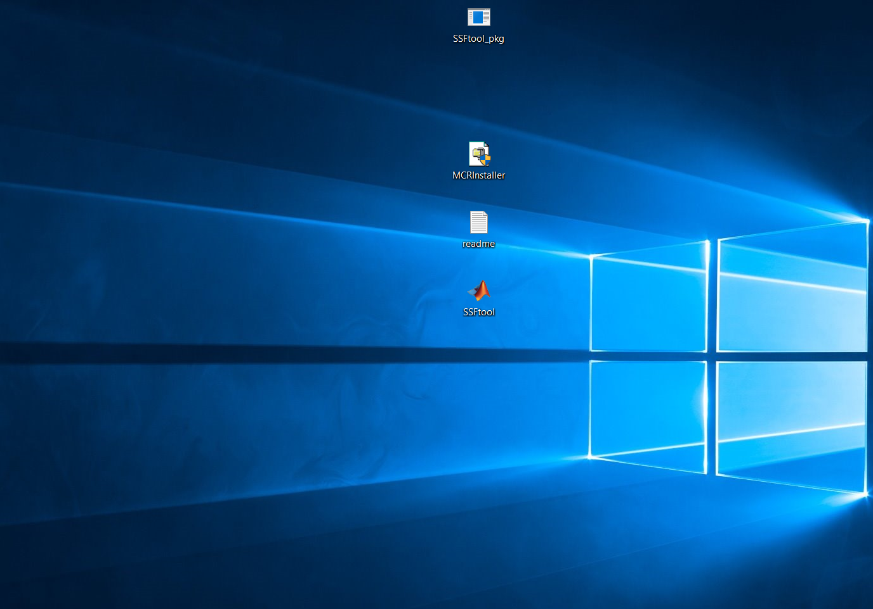
Fig 13. Running “SSFtool.exe”

Interface Overview
Figure 14 shows the overall Scoring Function Toolbox (SFT) interface.
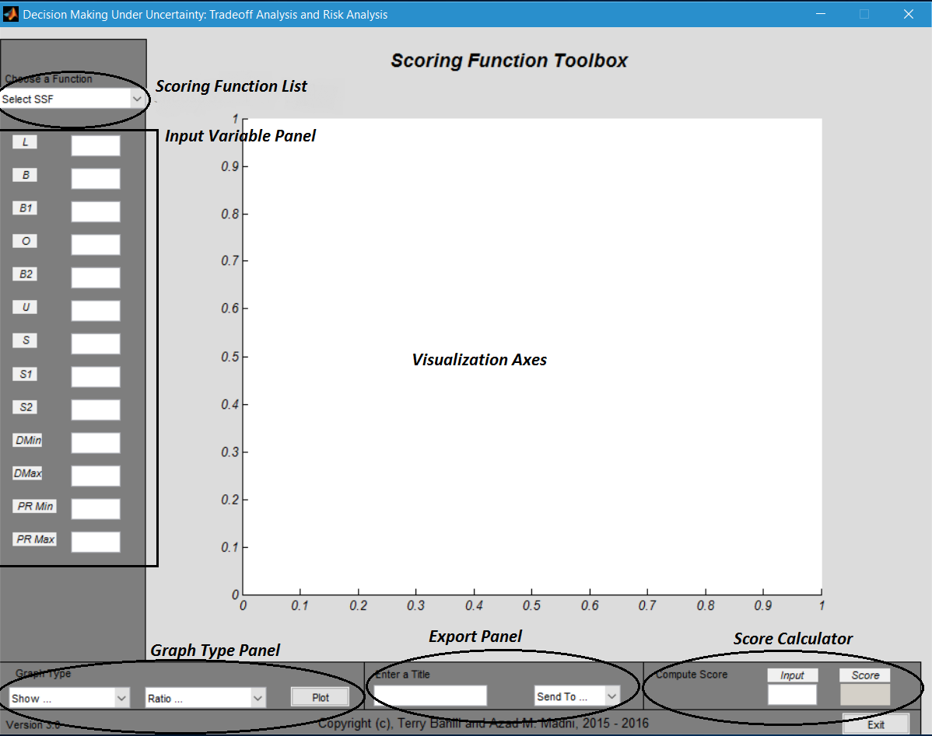
Fig14. Scoring Function Toolbox (SFT) interface

Scoring Function List
This List allows users to choose the desired Wymore Scoring Function known as a Standard Scoring Function (SSF). Users have the choice of 18 different Scoring Functions.

Variable Input Panel
This panel allows users to input necessary variable values to calculate and plot scoring functions. Variables that are not required for the chosen SSF will be turned off.

Graph Type Panel
This panel allows users to choose what information should be shown for x-axes. The user also has the option of defining the aspect ratio of the graph.

Export Panel
This panel allows users to export the plot to a standalone figure. It also gives the users an option to export the data used to generate the graph to an Excel file. Users can use those data to plot the exact graph in Excel.

Score calculator
This calculator allows users to calculate the score of a specific input variable in the domain range.

Illustrative Example

Selecting desired scoring function
This illustrative example will guide the user to plot a scoring function. For simplicity, SSF1 is chosen. Users can choose their desired scoring function from the drop down menu located at the top left corner. See Figure 15.
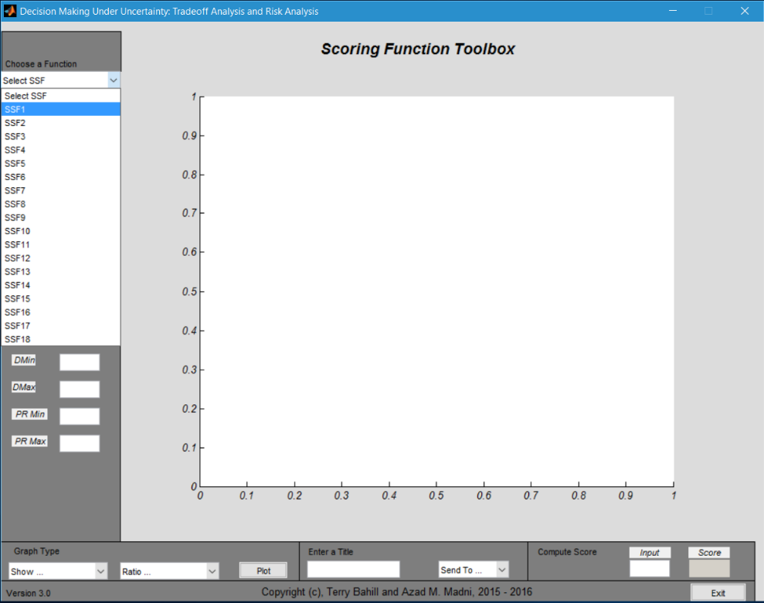
Fig 15. Choosing Standard Scoring Function
As the user selects SSF1, variables not required for calculating SSF1 will be turned off. The user then can input the values for the required (remaining) variables. See section 3.2 for details.

Inputting variables for a SSF
This section demonstrates how users can insert values for the required variables to calculate a specific scoring function. Table 1 describes each variable.
Variable | Description | Used in SSFs numbered
L | Lower threshold value | 1, 3, 5, 7, 9, 11, 13, 14, 15, 16
B | Baseline value | 1, 2, 3 , 4, 7, 8, 9 , 10
B1 | First baseline value | 5, 6, 11, 12
O | Optimum value | 5, 6,
P | Pessimum value | 11, 12
B2 | Second baseline value | 5, 6, 11, 12
U | Upper threshold value | 2, 3, 5, 8, 9, 11, 13, 14, 15, 16
S | Function’s slope | 1, 2, 3, 4, 7, 8, 9, 10
S1 | First slope | 5, 6, 11, 12
S2 | Second slope | 5, 6, 11, 12
DMin and DMax | Min and Max values of the range | 1 – 18
PR Min and PR Max | Min and Max values of the plotting range | 1 – 18
Table 1. Scoring Function Variables
As an illustrative example, figure 16 shows inserting values for variables L, B, S, DMin, DMax, PR Min, and PR Max to calculate SSF1.
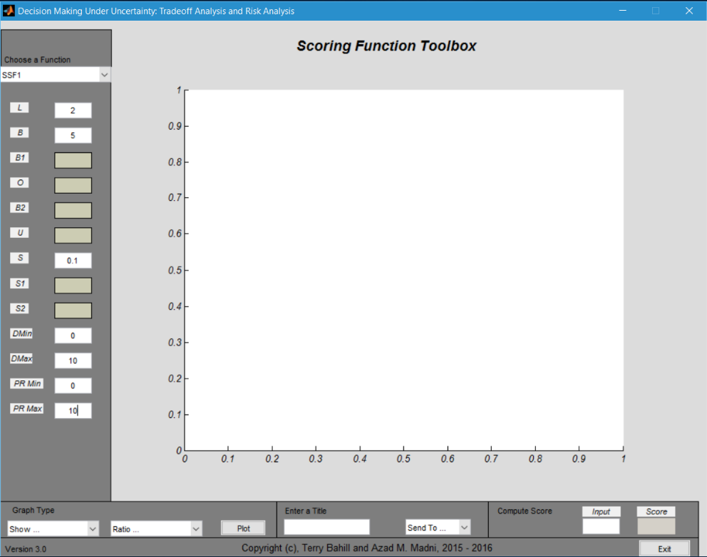
Fig 16. Inserting Values for SSF1

Choosing Graph Axes Type and Ratio
The user has two option to choose with respect to the type of the variable to be shown at x-axis. By choosing “Input Variable” the x-axis will show the numerical value on the x-axis. Choosing “Variables (e.g. L, U)” will only show the variables on the x-axis. Figures 17 and 18 demonstrate how to select these options.
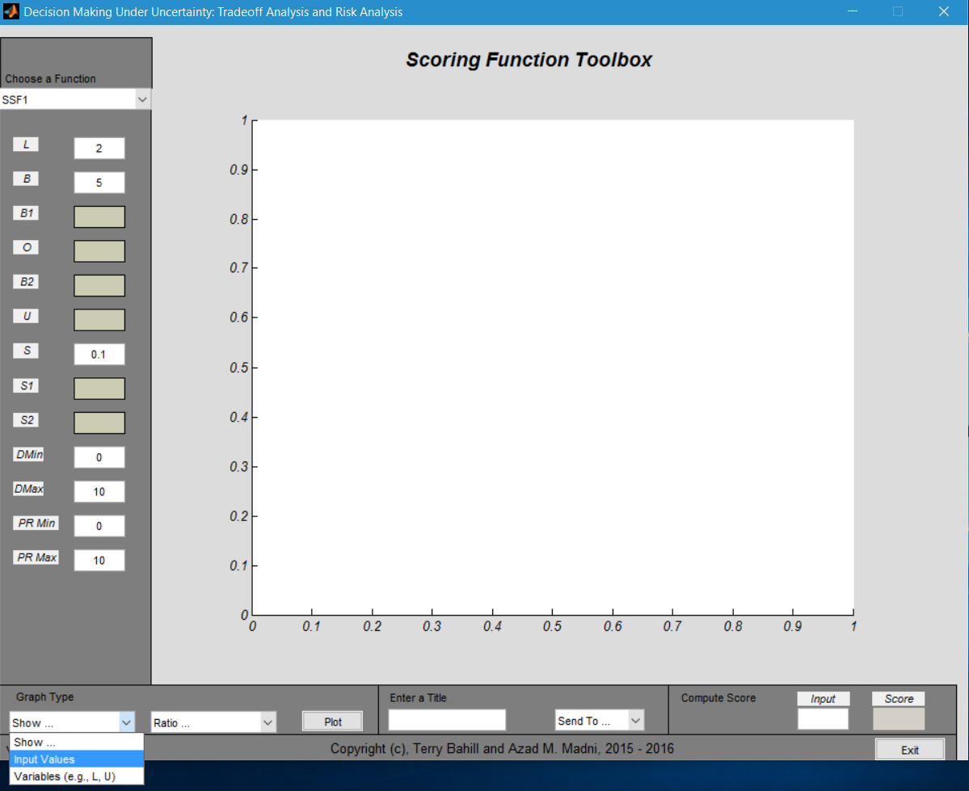
Fig 17. Selecting “Input Values” for the x-axis

Notice the change in the x-axis type in figure 18.
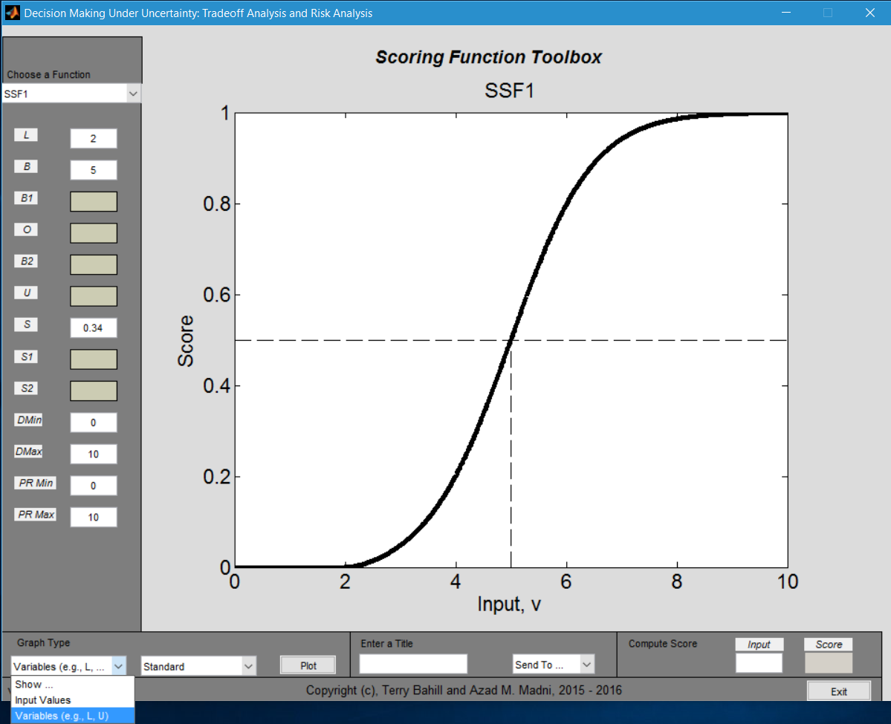
Fig 18. Selecting “Variables (e.g., L, U)
See figure 19 for the change in x-axis type.
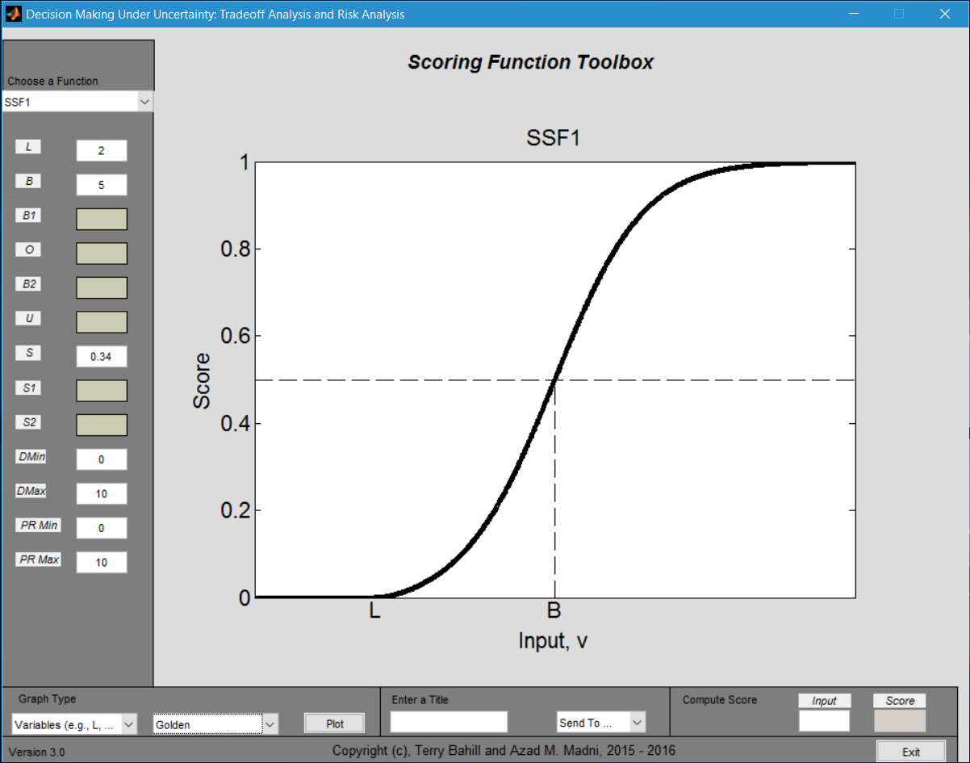
Fig 19. Plot showing variables on the x-axis
Users have also the option to choose different ratios for the graph. Figure 20 shows user selecting “Standard” ratio for the graph. This ratio is illustrated in Figure 20.
Figure 21 shows user that has selected “Golden” ratio. See Figure 21 and notice the change in the graph ratio (shape) by comparing it to Figure 20.

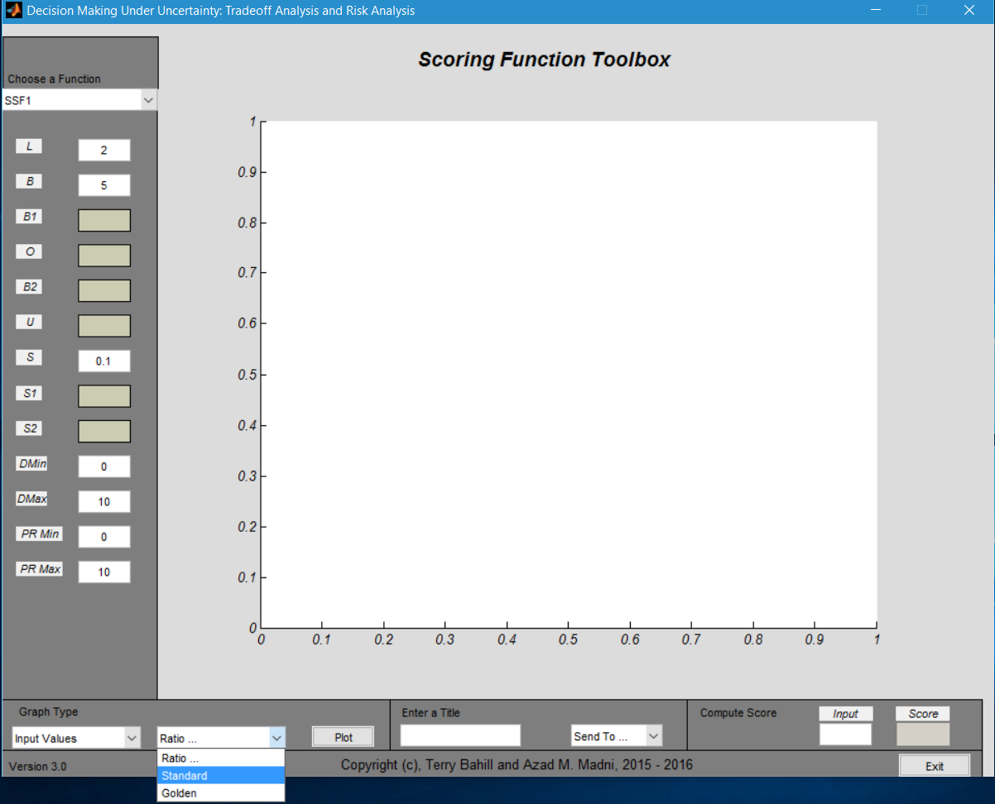
Fig 20. Users choose “Standard” ratio
Fig 21. User has chosen “Golden” ratio

Plotting and Dealing with Errors
Once user clicks on the “Plot” button, the plot will appear on the axes. However, this will only work when all the conditions are met. If any of the conditions are not met, a message will appear on the axis describing the error and what conditions have to be satisfied. (See Fig 22)
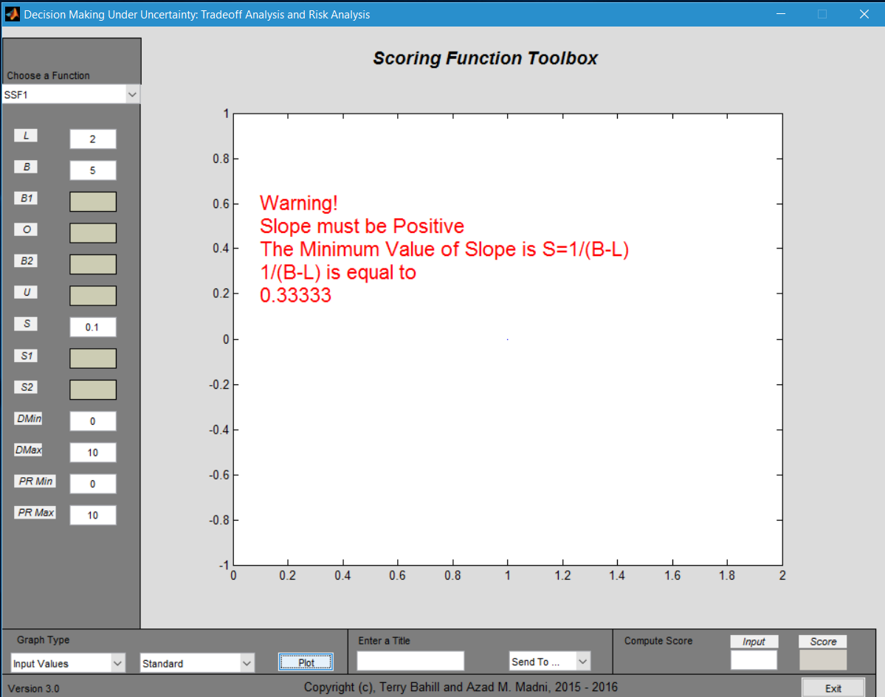
Fig 22. Error message in case of not satisfying conditions
Once all the conditions are met, the plot will appear on the axis. (See Figure 23)
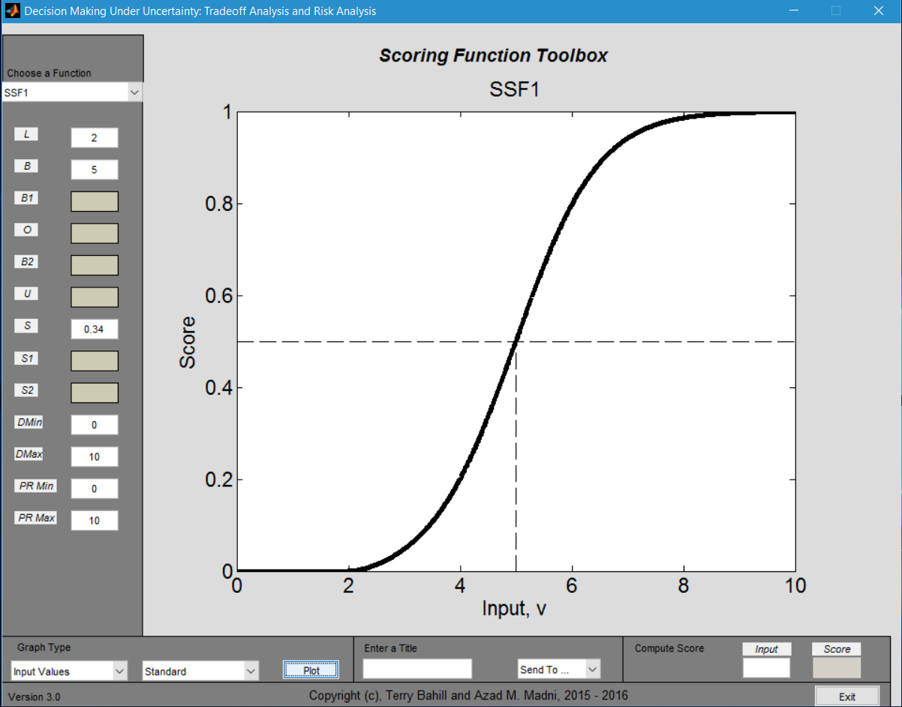
Fig 23. Successful plotting of a scoring function (with x-axis showing input values)
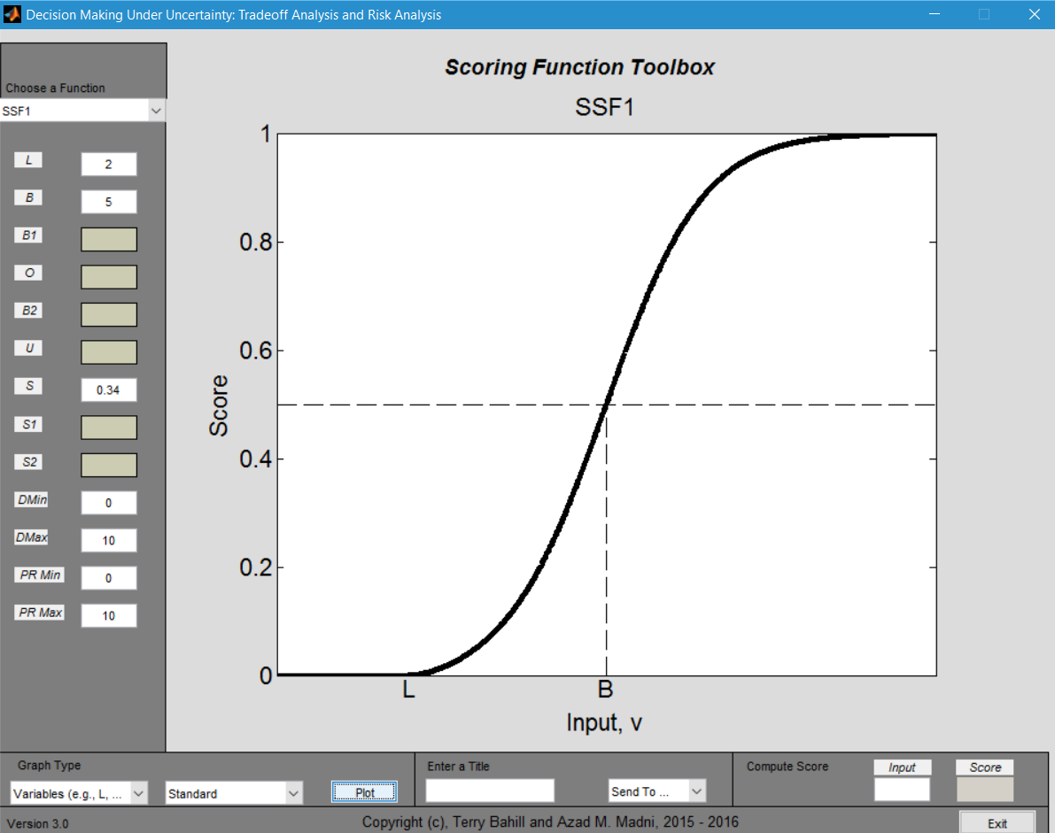
Fig 24. Successful plotting of a scoring function (with x-axis showing variables)

Exporting to a Figure
Users have also the option of exporting the plot to a standalone figure where they can zoom in, zoom out, save as, look at individual data points and change colors. In order to send the plot to a standalone figure, the user has to give the plot a name. Users can do that by typing the title in the box called “Enter a Title.” (See Fig 25 and 26) If no title is defined, then the software automatically titles the plot “Untitled.”

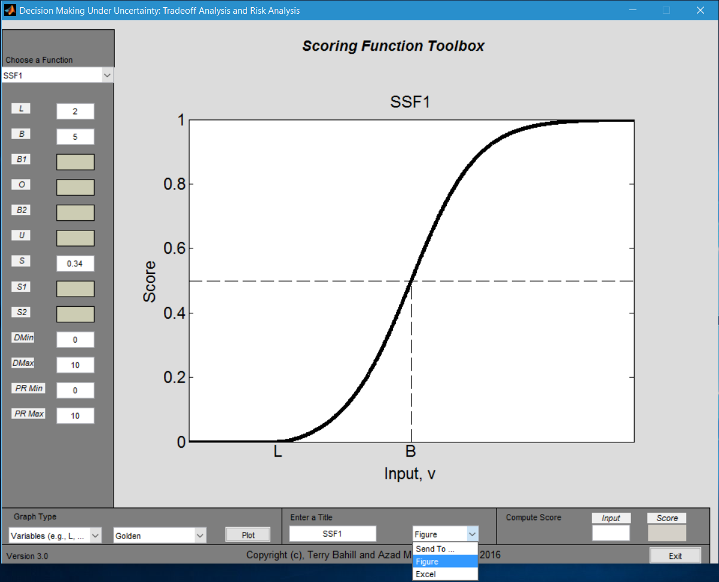
Fig. 25 Exporting to Figure
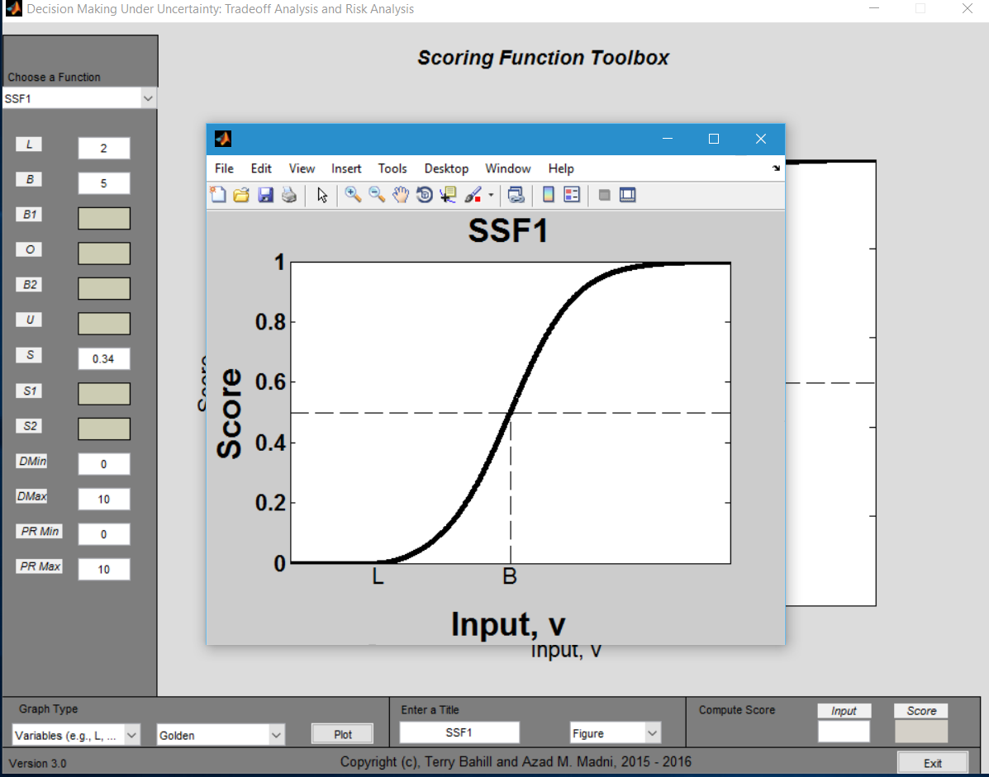
Fig 26. Standalone Figure

Saving the Plot
Users can save the plot with different extensions by going to File -> Save As (See Fig 27). Users have to input a title and specify the extension and save the file in the desired directory.
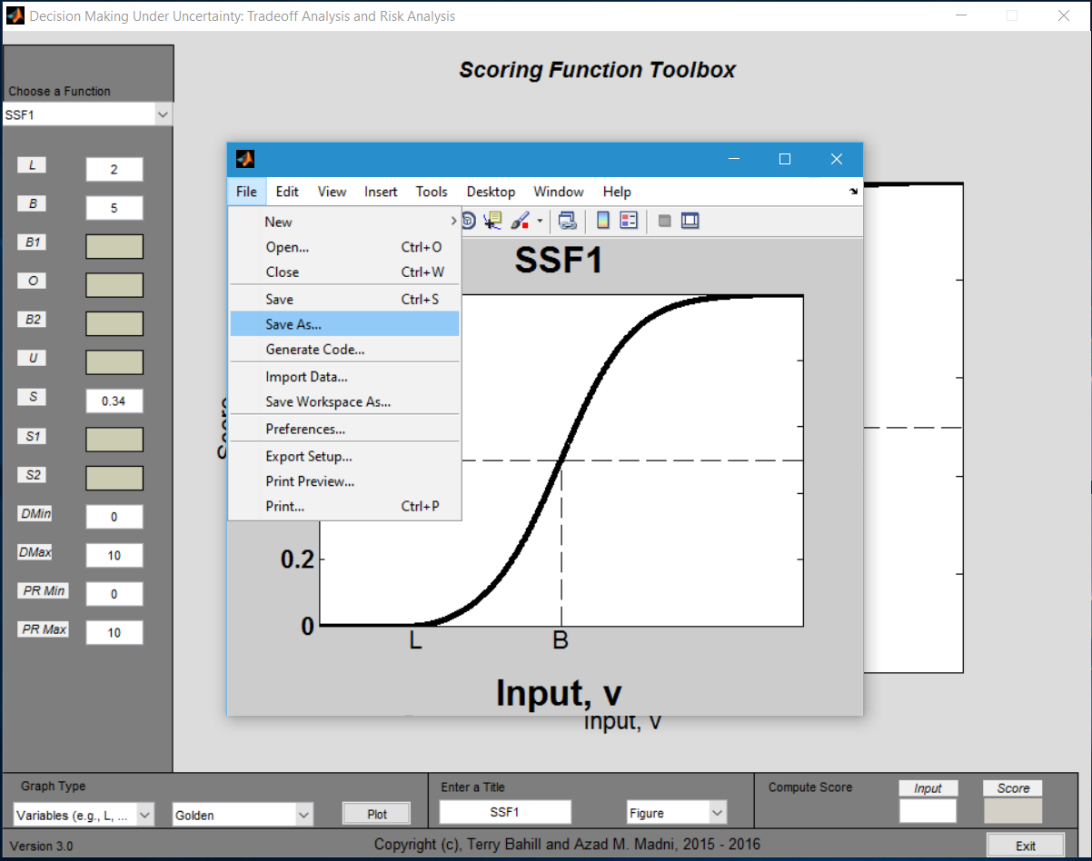
Fig 27 Saving the Figure

Looking at the Data Points
Users can also look at individual data points in the stand-alone figure. Users must select “Data Cursor” (see Fig 28). The next step, users must select a point on the figure and a small box will pop up and show the data points (see Fig 29)
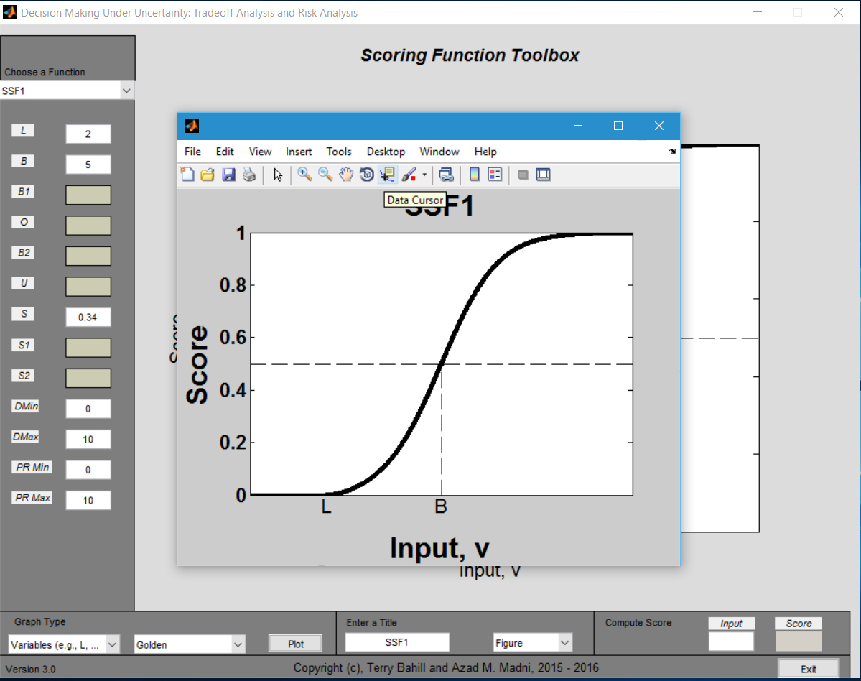
Fig 28. Selecting Data Cursor
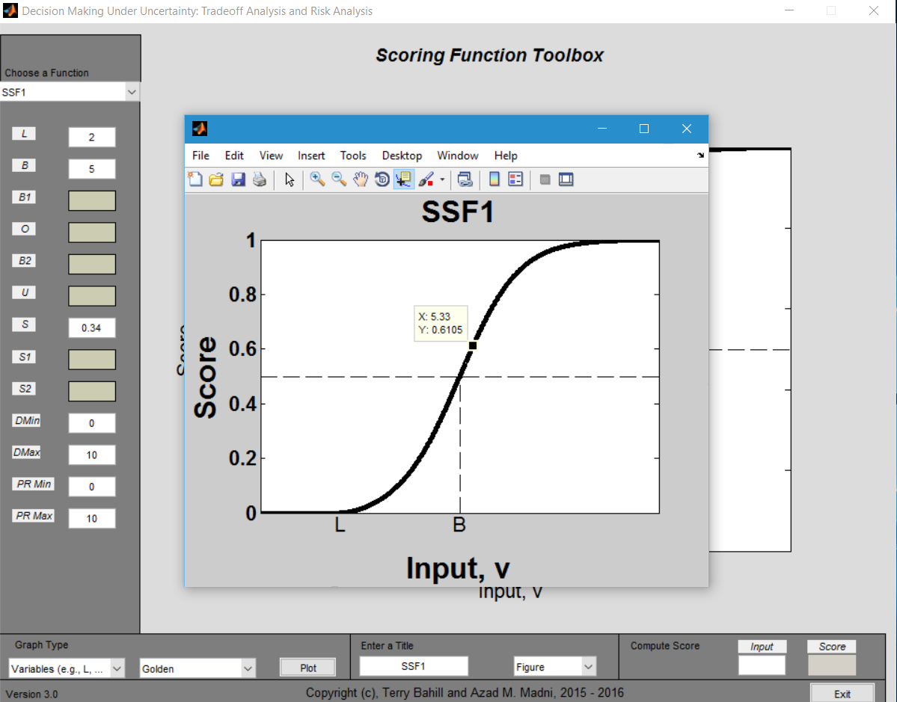
Fig 29 Selecting a point on the graph

Exporting Data to Excel File
Users also have the option of exporting the data to an Excel file. Those data can later be used to construct the same plot in Excel. Users must insert a title in the title box and select “Excel” from the drop down menu (see Fig 30). Once it is selected, an Excel file will be created in the same directory (see Fig 31). Users can open the file using Microsoft Excel. A screen shot of an Excel file is given in fig 32.

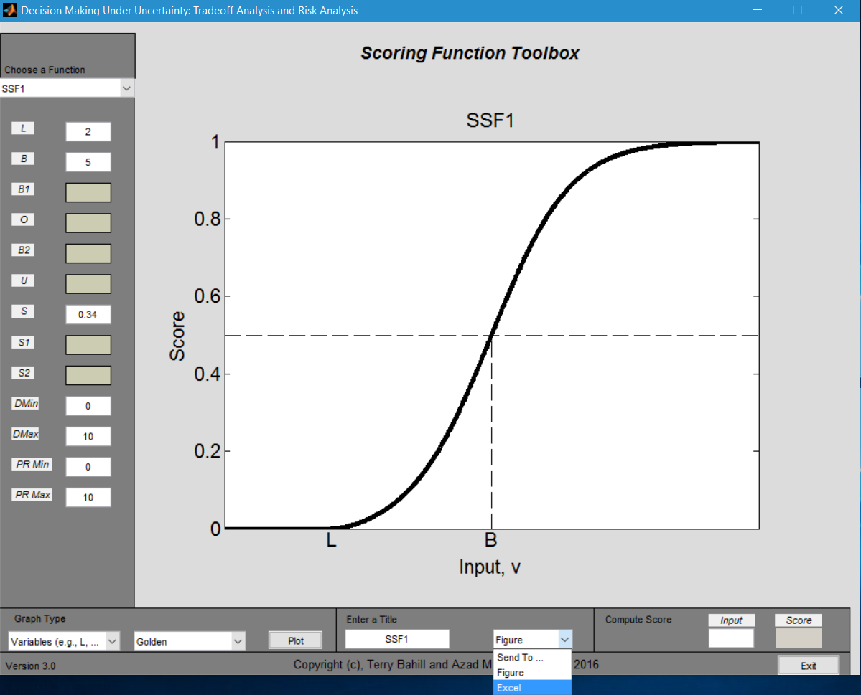
Fig 30. Exporting to Excel
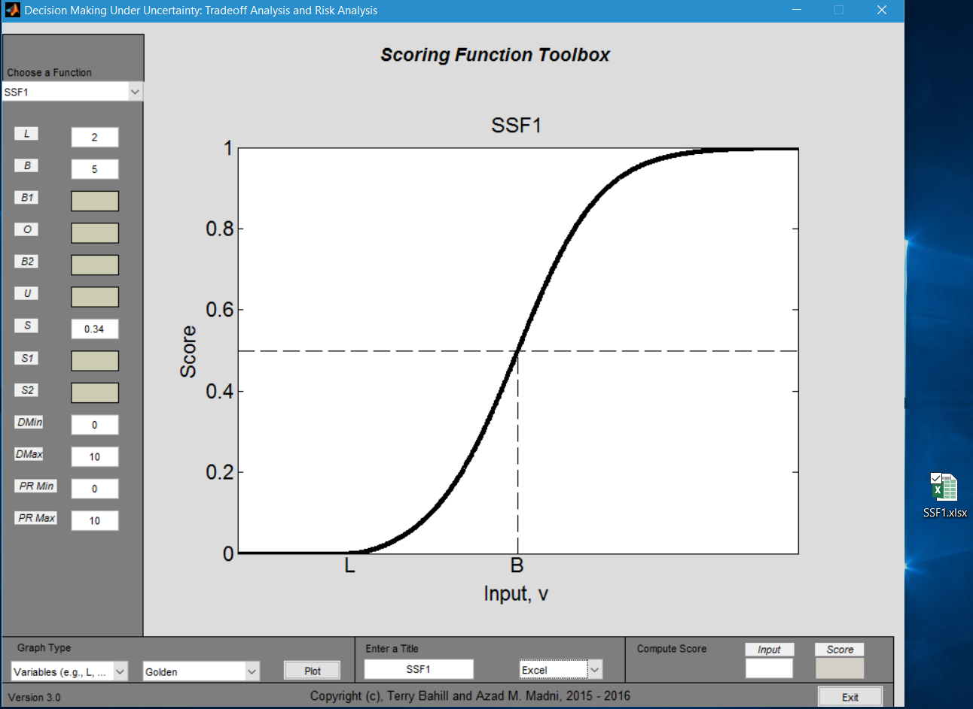
Fig. 31 Saving Excel files in the directory

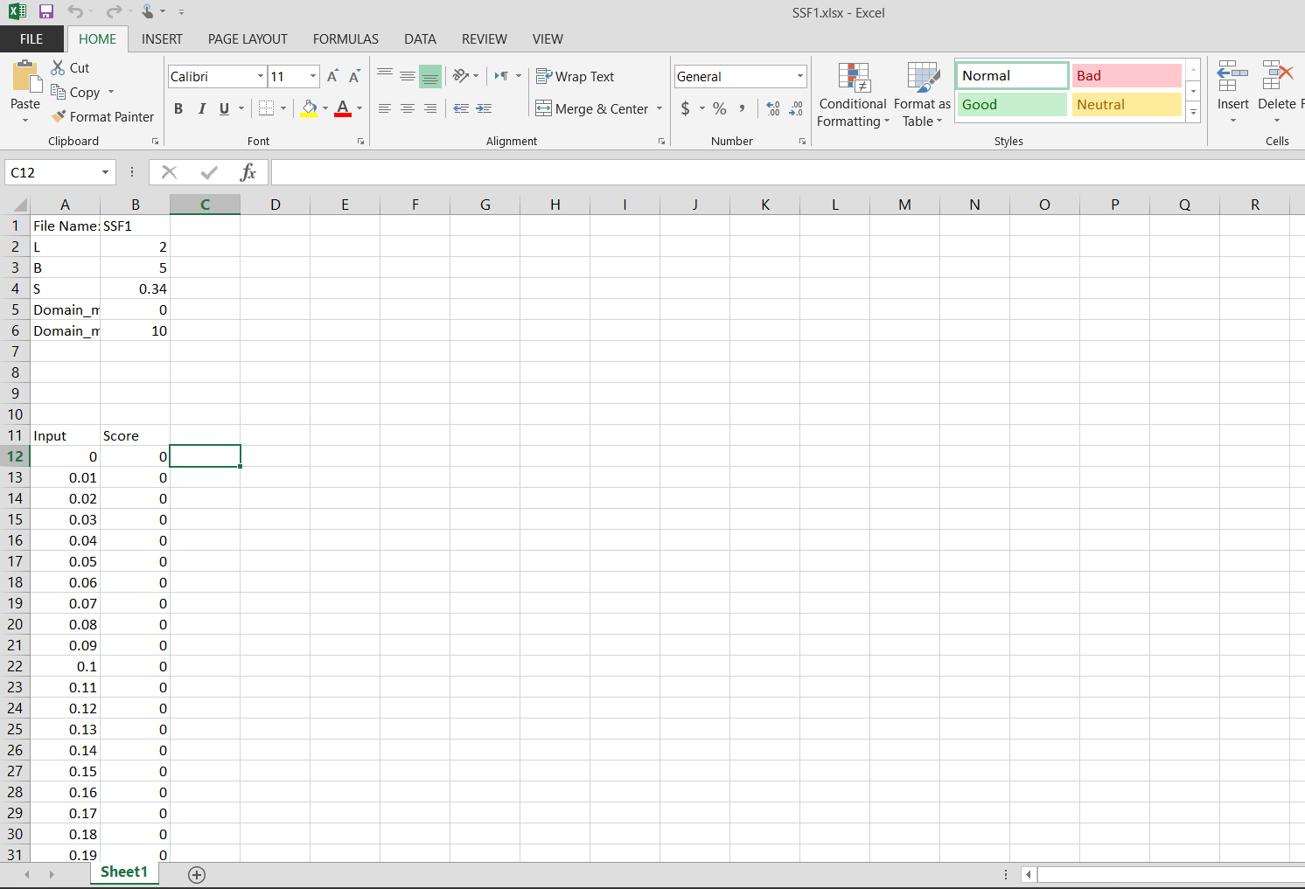
Fig 32 Excel File’s screen shot

Calculating Individual Scores
Users can also calculate each input’s score using the score calculator. They can do so by typing the input value on the box located on the left side and then clicking on the box on the right had side to see the score (see Fig 33).
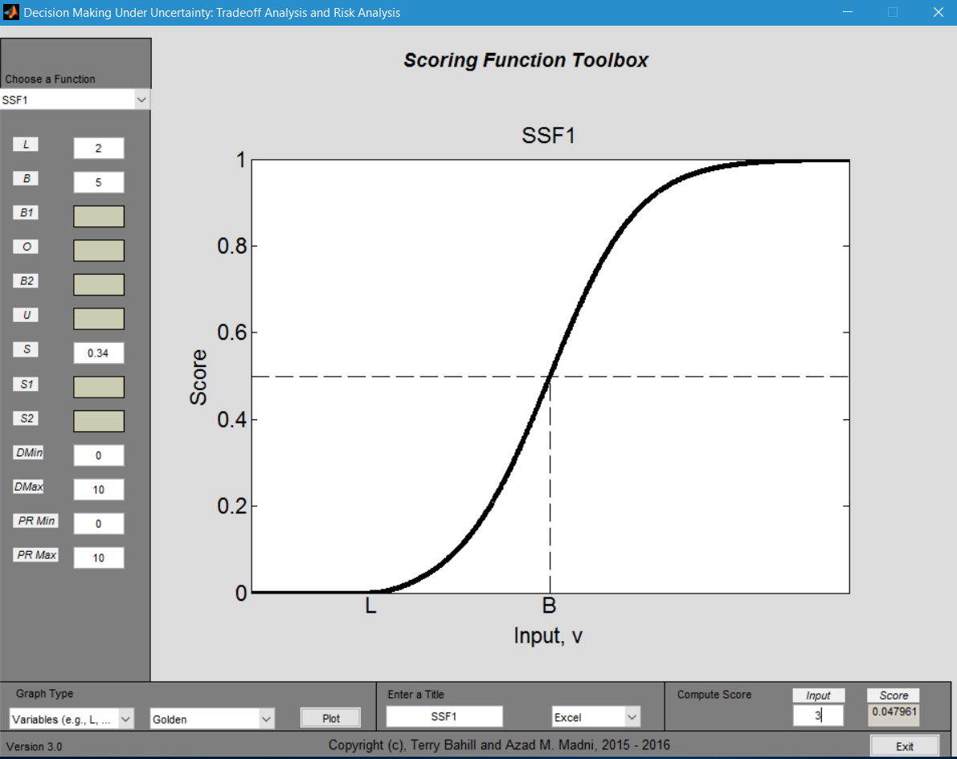
Fig 33 Calculating Individual Scores

