SIE 554A
Process Document
5 December 2005

By:

Matthew Dabkowski
Fabian Duarte
Rhea Frondozo
David Haas
Shahan Sikander

Table of Contents

1. Systems Engineering Document: Problem Situation 1
1.0. Configuration Management 1
1.1. Top Level System Function 1
1.2. History of the Problem and the Present System 1
1.3. The Customer 1
1.3.1. Owners 1
1.3.2. Financial Investors in the Project 1
1.3.3. Users/Operators of the System 1
1.3.4. Beneficiaries 1
1.3.6 Victims 2
1.3.6. Technical representatives to systems engineering 2
1.4. Technical Personnel and Facilities 2
1.4.1. Life Cycle Phase I (Requirement Development) 2
1.4.2. Life Cycle Phase 2 (Concept Development 2
1.4.3. Life Cycle Phase 3 (Full-Scale Engineering Development 2
1.4.4. Life Cycle Phase 4 (System Development) 2
1.4.5. Life Cycle Phase 5 (System Test and Integration) 2
1.4.6. Life Cycle Phase 6 (Operations Support and Modification) 2
1.4.7. Life Cycle Phase 7 (Retirement and Replacement) 2
1.5. System Environment 3
1.5.1. Social Impact 3
1.5.2. Economic Impact 3
1.5.3. Environmental Impact 3
1.5.4. Interoperability 3
1.6. Systems Engineering Management Plan 3
1.7. Alternatives 3
1.8. Metrics of Schedule, Cost, Performance and Risk 3
2. Systems Engineering Document: Process Customer Requirements 4
2.0. Configuration Management 4
2.1. Deficiency 4
2.2. Input/Output and Functional Requirements 4
2.2.1. Time scale 4
2.2.2. Inputs 4
2.2.3. Outputs 4
2.2.4. Matching function 4
2.3. Technology Requirements 4
2.3.1. Available money 5
2.3.2. Available time 5
2.3.3. Available components 5
2.3.4. Available techniques 5
2.3.5. Required interfaces 5
2.4. Input/Output Performance Requirements 5
2.5. Utilization of Resources Requirements 6
2.6. Trade-Off Requirements 6
2.7. System Test Requirement 6
2.8. Rationale for operational need 6
3. Systems Engineering Document: Process Derived Requirements 7
3.0. Configuration Management 7
3.1. The system requirement 7
3.2. Input/Output and Functional Requirement 7
3.2.1. Time scale 7
3.2.2. Inputs 7
3.2.3. Input trajectories 8
3.2.4. Outputs 9
3.2.5. Output trajectories 9
3.3. Technology requirement 10
3.3.1. Available money 10
3.3.2. Available time 10
3.3.3. Available components 10
3.3.4. Available techniques 10
3.3.5. Required interfaces 10
3.3.6. Form, fit and other restrictions 11
3.3.7. Standards and specifications 11
3.4. Input/Output Performance Requirement 11
3.4.1. Definition of Performance Figures of Merit 11
3.4.2. Lower, upper, baseline, and scoring parameters 11
3.4.3. Weighting criteria 14
3.5. Utilization of Resources Requirement 14
3.5.1. Definition of Resource Figures of Merit 14
3.5.2. Lower, upper, baseline, and scoring parameters 14
3.7.3. Utilization of resources tests 16
3.5.3. Weighting Criteria 17
3.6. Trade-Off Requirement 17
3.7. System Test Requirement 17
3.7.1. Test plan 17
3.7.1.1. Explanation of test plan 17
3.7.1.2. Test Trajectory 1 18
3.7.1.3. Test Trajectory 2 18
3.7.1.4. Test Trajectory 3 18
3.7.1.5. Test Trajectory 4 18
3.7.2. Input/output performance tests 18
3.7.3. Utilization of resources tests 19
3.8. Rationale for operational need 19
4. Systems Engineering Document: Process Systems Requirements Validation 20
4.0. Configuration Management 20
4.1. Input/Output Functional Design 20
4.2. Technology for the Buildable for the System 20
4.3. Input/Output Performance Requirement 20
4.4. Cost Requirement 20
4.5. Schedule Requirement 20
4.6. Test Requirement 20
5. Systems Engineering Document: Process Concept Exploration 22
5.0. Configuration Management 22
5.1. Process Systems 22
5.1.1. System Design Concept 1 (Do Nothing) 22
5.1.2. System Design Concept 2 (Pareto collaboration) 22
5.1.3. System Design Concept 3 (Egalitarian collaboration) 22
5.1.4. System Design Concept 4 (Lie/Cheat/Steal) 22
5.2. Evaluation Criteria 22
5.2.1. I/O Requirements 22
5.2.2. U/R Requirements 23
5.3. Analytical Hierarchy Process 23
5.3.1. Trade-off Matrix 24
5.3.2. Sensitivity Analysis 25
5.4. Recommended Alternatives 25
5.5. Cognitive Bias 25
6. Systems Engineering Document: Process Use Case Model 26
6.0. Configuration Management 26
6.2. Use Case Model: Process 26
6.2.1. High Level 26
6.2.2. Low Level 27
6.3. Use Case Report 27
6.3.1. High Level Use Cases 27
6.3.2. Low Level Use Cases 28
6.4. Use Case Requirements Specification 29
6.4.1. Specific Requirements 29
6.4.2. Functional Requirements 30
6.4.3. Nonfunctional Requirements 30
6.4.4. Supplementary Requirements Specification 30
7. Systems Engineering Document: Process Design Model 31
7.0. Configuration Management 31
7.1. System interfaces 31
7.2. Design model 31
7.2.1. Class diagram 32
7.2.2. Communication diagrams 32
7.2.2.1. Communication diagram for Do Project use case 32
7.2.3. Sequence diagrams 33
7.2.3.1. Sequence diagram for Do Project use case 33
7.2.3.2. Sequence diagram for Present Project use case 34
7.2.4. Component diagram 34
7.2.5. Deployment diagram 35
7.3. Implementation model 35
7.4. Operational model 35
8. Systems Engineering Document 8: Models, Mapping and Management 36
8.0. Configuration Management 36
8.1. Document Structure 36
8.2. Document Mappings 36
8.2.1. Process Mappings 36
8.3. Activity Diagrams 38
8.3.1. Process Activity Diagrams 38
8.4. User Manual 38
8.5. Risk Analysis 38
8.5.1. Quantitative Risk List 38
8.5.2. Qualitative Risk List 39
8.6. Schedule 39
8.6.1. Gantt chart and Network Activity Diagram 39
8.6.2. Process Burn-Up Charts 42
8.7. Project Work Breakdown Structure 46
Appendix A: Glossary of Terms 48
Appendix B: Process User Manual 49

1. Systems Engineering Document: Problem Situation

1.0. Configuration Management

Document Lead: MD
Assistant: RF

Date Version Team Members
10/3 0.1 DH
11/22 0.2 DH

1.1. Top Level System Function

For the student enrolled in SIE-554a who needs to understand the systems engineering process the SIE-554a final project that allows the student experience applying systems knowledge, unlike those which do not properly distinguish between product and process, our process document separates all process knowledge from the product knowledge contained in the product document.

1.2. History of the Problem and the Present System

For eons since time immemorial students in SIE-554a have honed valuable systems engineering skills through perseverance in team environments. Distance learning as well as remote team collaboration has helped foster a unique mixture of courage, strength and determination as well as an underlying motivation to succeed at all costs on the final project.

1.3. The Customer

1.3.1. Owners

The process will be owned by the current team members enrolled in SIE-554a.

1.3.2. Financial Investors in the Project

The financial investors in the process are the individuals, family members, corporations and military; that have invested in individuals with complete trust in their ability to succeed in SIE-554a.

1.3.3. Users/Operators of the System

The process will be used and operated by the current team members enrolled in SIE-554a.

1.3.4. Beneficiaries

The beneficiaries of the process are the financial investors, students and faculty of the SIE-554a department.

1.3.5. Victims

The victims of the process are the family members, friends, and loved ones who never get to see the students anymore because of their complete devotion to the project. Additional victims of an unsuccessful project will be the financial investors, the professor and university, as well as the very students themselves.

1.3.6. Technical representatives to systems engineering

The technical representatives to the system are the professor, guest lecturers, and departmental faculty of the SIE department.

1.4. Technical Personnel and Facilities

1.4.1. Life Cycle Phase I (Requirement Development)

Process requirements data will be developed on an ad hoc time-to-turn-in basis.

1.4.2. Life Cycle Phase 2 (Concept Development )

Process concept will be developed in accordance to student whims.

1.4.3. Life Cycle Phase 3 (Full-Scale Engineering Development )

Full-scale process engineering will be conducted on home computers, laptops, via e-mail and phone collaborations.

1.4.4. Life Cycle Phase 4 (System Development)

System development of the process will be conducted at the student’s leisure.

1.4.5. Life Cycle Phase 5 (System Test and Integration)

The process will be integrated and tested based on professor feedback from interim document drafts.

1.4.6. Life Cycle Phase 6 (Operations Support and Modification)

The system will be considered operational if it receives a passing mark in the class.

1.4.7. Life Cycle Phase 7 (Retirement and Replacement)

The system will be immediately retired upon completion and submission to be replaced by future generations of SIE-554a students.

1.5. System Environment

1.5.1. Social Impact

The social impact of the process is that of individual student’s learning how to cooperate and function as team members on a project of such immense proportion.

1.5.2. Economic Impact

The economic impact of the process is renewed support from the financial investors.

1.5.3. Environmental Impact

The impact on the environment from the process is the number of trees chopped down to create the documents and the amount of greenhouse gases emitted from using the computers and transportation.

1.5.4. Interoperability

The process must interoperate with team member’s individual schedules and extra-curricular commitments. The process should ideally not present undue stress on team member’s lives.

1.6. Systems Engineering Management Plan

The project will be designed according to the eight design documents. Ideally there should be multiple drafts of each document as needed.

1.7. Alternatives

Alternative modes of communication, collaboration techniques and distance meetings will be explored and implemented based on the ability of the team.

1.8. Metrics of Schedule, Cost, Performance and Risk

Metrics will be based on direct instructor feedback as well as marks given on interim document revisions. Schedule metrics will accordingly be based on time-to-completion with early submission receiving a higher metric. Cost, performance and risk will be measured by the ability to submit on-time with the fewest mistakes.

2. Systems Engineering Document: Process Customer Requirements

2.0. Configuration Management

Document Lead: RF
Assistant: MD

Date Version Team Members
9/29 0.1 RF
10/2 0.2 FD
10/3 1.0 MD,FD,DH,RF,SS

2.1. Deficiency

The project was created to provide students with an opportunity to understand and apply the principles and tools of systems engineering, hence, enhancing their technical and personal abilities.

2.2. Input/Output and Functional Requirements

2.2.1. Time scale

The project is not to last more than 5 months, and 10 hours a week per student is expected.

2.2.2. Inputs

The inputs are as follows:

- Students who are not trained on Systems Engineering subject matter.
- Reference books and material, computers, and similar resources.
- Guidelines and lecture material provided by the instructor.

2.2.3. Outputs

The outputs are as follows:

- Students who are trained on Systems Engineering subject matter.
- System documentation.
- Actual system.

2.2.4. Matching function

The system outputs map directly to the inputs given – i.e., once the inputs are provided, tangible outputs must be delivered.

2.3. Technology Requirements

2.3.1. Available money

A predetermined cost of under $100 will be maintained; any further investments will be on a need-to basis.

2.3.2. Available time

The system and all the corresponding system documents must be completed by December 7th, 2005.

2.3.3. Available components

Project components are as following:

- Students
- Mentor (the instructor and his teaching assistant)
- Reference documents from similar projects
- A common mode of communication

2.3.4. Available techniques

The available technologies are:

- Computers
- USB drives
- Internet
- Computer tools like Rational Rose; Microsoft Project, Word, Excel, PowerPoint etc.

2.3.5. Required interfaces

Required interfaces will be:

- Presentations, both oral and written
- Notes
- Documentation
- Emails
- Interactive meetings

2.4. Input/Output Performance Requirements

Quality of work must be more than 80%.

2.5. Utilization of Resources Requirements

The total project cost should be less than $100.
The project time span should be less than 5 months.

2.6. Trade-Off Requirements

The performance and resource requirements will be given equal weights in the trade-off analysis.

2.7. System Test Requirement

System will be accepted if:

- Each individual document meets the necessary requirements as specified in Dr. Bahill’s “The Eight Systems Engineering Documents.”
- All the system documentation is submitted by December 7th, 2005.
- The solution provided in “The Eight Systems Engineering Documents” is a feasible solution.
- The solution has been approved by all of the team members.
- The solution can be delivered in accordance to the guidelines for submission set by Dr. Bahill.

2.8. Rationale for operational need

Dr. Bahill provided the specifications via class notes, lectures and feedback during the course of the class.

3. Systems Engineering Document: Process Derived Requirements

3.0. Configuration Management

Document Lead: MD
Assistant: RF

Date Version Team Members
10/17 0.3 RF
10/18 0.4 FD
10/19 1.0 MD,FD,DH,RF,SS

3.1. The system requirement

The System Design Requirement involves the following components:

- Input/Output and Functional Requirement
- Technology requirement
- Input/Output Performance Requirement
- Utilization of Resources Requirement
- Trade-Off Requirement
- System Test Requirement

3.2. Input/Output and Functional Requirement

3.2.1. Time scale

The project is not to last more than 5 months, and 10 hours a week per student is expected. TRP0 is the time scale of the system, expressed in minutes.

TRP0 = ((5 months * 30 days/month ) + 3 days)* 24 hours/day * 60 minutes/hour = 218,880 minutes

Note: In the calculation above, an extra day was added for the 1 month (Oct) which has 31 days, instead of just 30.

3.2.2. Inputs

IRP0 represents the set of systems inputs. There are three input ports

IRP0 = IR1P0 x IR2P0 x IR3P0

IR1P0 is the set of students who are not trained on Systems Engineering subject matter and is broken down as follows

OR1P0 = Students = {Student1, Student2, Student3, Student4, Student5}

And the possible values of Student1 through Student5 are the names of the teammates working on this system

StudentX = {Name, Team, SubjectMatterExpert}

IR2P0 are the set of resources available to the students

IR2P0 = Resources = {Books, Notes, Computers}
where the values of Books, Notes and Computers can be broken down as follows

Books = {Engineering Modeling and Design, Who Says Elephants Can’t Dance}

Notes = {SIE554A Course Notes, SIE554 Instructor Slides}

Computers = {Home PC’s, Student’s Laptops, University of Arizona Computers}

IR3P0 are the set of instructor lectures/guidelines.

IR3P0 = Instructors = {Bahill, Gissing}

3.2.3. Input trajectories

IRTP0 is the set of input trajectories for this system, the set of all possible inputs (IRP0) over the time scale (TRR0)

Trajectory 1: The system will only account for IR1P0, which is in the range of people with Bachelors Degrees to PhDs not in Systems Engineering

Trajectory 2: The system will only account for OR1P0, which is in the range of Student1 to Student5

Trajectory 3: The system will only account for IR2P0, which is in the range of Books, Notes, Computers

Trajectory 4: The system will only account for Books, which is in the range of Engineering Modeling and Design and Who Says Elephants Can’t Dance

Trajectory 5: The system will only account for Notes, which is in the range of SIE554A Course Notes, SIE554A Instructor Slides, recorded SIE 554A video classes

Trajectory 6: The system will only account for Computers, which is in the range of Home PC’s, Student’s Laptops, University of Arizona Computers

Trajectory 7: The system will only account for IR3P0, which is in the range of instructor lectures to guidelines

Trajectory 8: The system will only account for IR3P0, which is in the range of Dr. Bahill to Gissing

3.2.4. Outputs

ORP0 represents the system outputs for our system, and there are 3 output ports.

ORP0 = OR1P0 x OR2P0 x OR3P0

OR1P0 are the students who are trained on Systems Engineering subject matter, broken down as follows

OR1P0 = Students = {Student1, Student2, Student3, Student4, Student5}

And the possible values of Student1 through Student5 are the names of the teammates working on this system

StudentX = {Name, Team, SubjectMatterExpert}

OR2P0 is the set of system documentation that accompanies the system.

OR2P0 = Documents = {Doc1,Doc2, Doc3,Doc4,Doc5,Doc6,Doc7,Doc8}

OR3P0 is the actual system, which is a process to follow in order to produce a product.

OR3P0 = Process = {Step1, Step2, Step3, Step4, Step5, Step6, Step7, Step8}

3.2.5. Output trajectories

OTRP0 is the set of all output trajectories for our system. ORTP0 is the set of all possible outputs (ORP0) over the time scale (TRP0)

Trajectory 1: The system will only account for OR1P0, which will produce students who are trained on Systems Engineering subject matter

Trajectory 2: The system will only account for OR1P0, which are Student1, Student2, Student3, Student4, Student5

Trajectory 3: The system will only account for OR2P0, which is the set of system documentation that accompanies the system.

Trajectory 4: The system will only account for OR2P0, which is Doc1,Doc2,Doc3,Doc4,Doc5,Doc6,Doc7,Doc8

Trajectory 5: The system will only account for OR3P0, which is a process to follow in order to produce a product

Trajectory 6: The system will only account for OR3P0, which is Step1, Step2, Step3, Step4, Step5, Step6, Step7, Step8

3.3. Technology requirement

3.3.1. Available money
A predetermined cost of under $100 will be maintained; any further investments will be on a need-to basis. The $100 should be able to cover any printing costs, copying costs and communications costs.

3.3.2. Available time

The system and all the corresponding system documents must be completed by December 7th, 2005.

3.3.3. Available components

Project components are as following:

1. Students
2. Mentor (the instructor and his teaching assistant)
3. Reference documents from similar projects
4. A common mode of communication (email, phone conferences, face-to-face meetings)

3.3.4. Available techniques

The available technologies are:

1. Computers (Home PC’s, Laptops, University of Arizona computers)
2. USB drives
3. Internet
4. Computer tools like Rational Rose; Microsoft Project, Word, Excel, PowerPoint etc.

3.3.5. Required interfaces

Required interfaces will be:

1. Presentations, both oral and written
2. Notes
3. Documentation
4. Emails
5. Interactive meetings

3.3.6. Form, fit and other restrictions

The restrictions to this system are that all students on a team must be held accountable for doing equal portions of work.

3.3.7. Standards and specifications

In performing the work for this process, all students must adhere to the University of Arizona policies and procedures.

3.4. Input/Output Performance Requirement

The overall performance figure of merit is denoted IF0P0 and is computed as follows in the next section.

3.4.1. Definition of Performance Figures of Merit

The overall Performance Figure of Merit is defined as IF0P1 where

IF0P1 = (ISF1P0 * IW1P0) + (ISF2P0 * IW2P0) + . . . + (ISFnP0 * IWnP0)

n = the total number of I/O Performance Criteria

3.4.2. Lower, upper, baseline, and scoring parameters

IFiP0 = the i^{th} figure of merit measured per the test plan,
IBiP0 = the baseline value for the i^{th} figure of merit,
ILTHiP0 = lower threshold for the i^{th} figure of merit,
ISFiP0 = score for the i^{th} figure of merit,
ISiP0 = scoring function for the i^{th} figure of merit,
ISLiP0 = slope for the i^{th} figure of merit,
IUTHiP0 = upper threshold for the i^{th} figure of merit,
IWiP0 = weight for the i^{th} figure of merit, and
SSF = standard scoring function

- Correctness:

Score: IS1P1 = SSF (ILTH1P1, IB1P1, IUTH1P1, ISL1P1)

Units | Subjective rating from 1 -10 (10 being the simplest → the best)
Lower Threshold | ILTH1P1 | 0
Baseline | IB1P1 | 5
Upper Threshold | IUTH1P1 | 10
Slope | ISL1P1 | 0.25

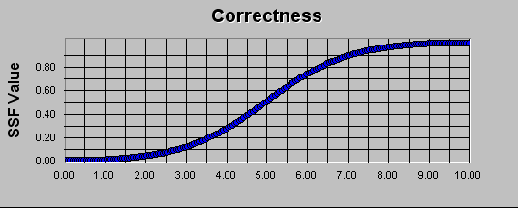

- Quality:

Score: IS2P1 = SSF (ILTH2P1, IB2P1, IUTH2P1, ISL2P1)

Units | Subjective rating from 1 -10 (10 being the simplest → the best)
Lower Threshold | ILTH2P1 | 0
Baseline | IB2P1 | 5
Upper Threshold | IUTH2P1 | 10
Slope | ISL2P1 | 0.25

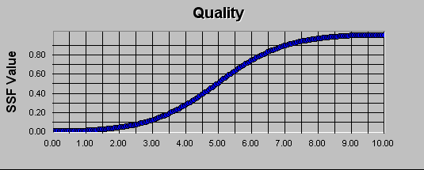

- Thoroughness:

Score: IS3P1 = SSF (ILTH3P1, IB3P1, IUTH3P1, ISL3P1)

Units | Subjective rating from 1 -10 (10 being the simplest → the best)
Lower Threshold | ILTH3P1 | 0
Baseline | IB3P1 | 5
Upper Threshold | IUTH3P1 | 10
Slope | ISL3P1 | 0.25
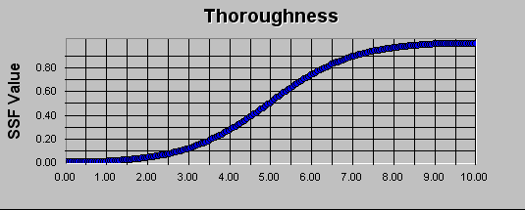

- Efficiency:

Score: IS4P1 = SSF (ILTH4P1, IB4P1, IUTH4P1, ISL4P1)

Units | Subjective rating from 1 -10 (10 being the simplest → the best)
Lower Threshold | ILTH4P1 | 0
Baseline | IB4P1 | 3
Upper Threshold | UUTH4P1 | 10
Slope | USL4P1 | 0.5

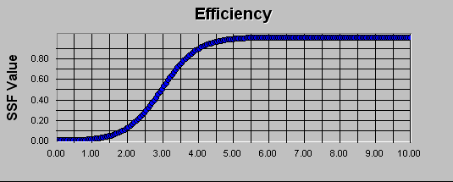

- Clarity:

Score: IS5P1 = SSF (ILTH5P1, IB5P1, IUTH5P1, ISL5P1)

Units | Subjective rating from 1 -10 (10 being the simplest → the best)
Lower Threshold | ILTH5P1 | 0
Baseline | IB5P1 | 7
Upper Threshold | IUTH5P1 | 10
Slope | ISL5P1 | 0.5

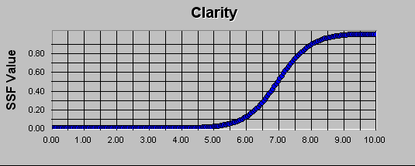

3.4.3. Weighting criteria

The importance value of each Performance Criteria was gauged on a 1-10 scale (1 being the least important, 10 being the most). The weight for each criterion (IWiP0) was then calculated by taking its importance value and dividing it by the sum of the importance values for all criteria. (Note: The sum of the IWiP0 = 1).

 | Figure of Merit | Value | IWiP0
1 | Correctness | 10 | 0.28571
2 | Quality | 8 | 0.22857
3 | Thoroughness | 7 | 0.20000
4 | Efficiency | 4 | 0.11429
5 | Clarity | 6 | 0.17143

3.5. Utilization of Resources Requirement

The Utilization of Resources of the system will be measured as a weighted average of the criteria outlined below.

3.5.1. Definition of Resource Figures of Merit

The overall Utilization Figure of Merit is defined as UF0P0 where

UF0P0 = (USF1P0 * UW1P0) + (USF2P0 * UW2P0) + . . . + (USFnP0 * UWnP0)

n = the total number of Utilization of Resources Criteria

3.5.2. Lower, upper, baseline, and scoring parameters

UFiP0 = the i^{th} figure of merit measured per the test plan,
UBiP0 = the baseline value for the i^{th} figure of merit,
ULTHiP0 = lower threshold for the i^{th} figure of merit,
USFiP0 = score for the i^{th} figure of merit,
USiP0 = scoring function for the i^{th} figure of merit,
USLiP0 = slope for the i^{th} figure of merit,
UUTHiP0 = upper threshold for the i^{th} figure of merit,
UWiP0 = weight for the i^{th} figure of merit, and
SSF = standard scoring function

- Acquisition Time:

Score: US1P1 = SSF (ULTH1P1, UB1P1, UUTH1P1, USL1P1)

Units | Months
Lower Threshold | ULTH1P1 | 1
Baseline | UB1P1 | 4
Upper Threshold | UUTH1P1 | 6
Slope | USL1P1 | -0.5

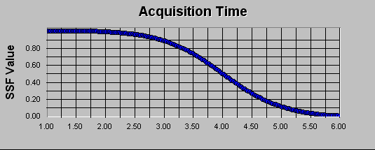

- Acquisition Cost:

Score: US2P1 = SSF (ULTH2P1, UB2P1, UUTH2P1, USL2P1)
Units | Dollars
Lower Threshold | ULTH2P1 | 0
Baseline | UB2P1 | 20
Upper Threshold | UUTH2P1 | 100
Slope | USL2P1 | -0.05

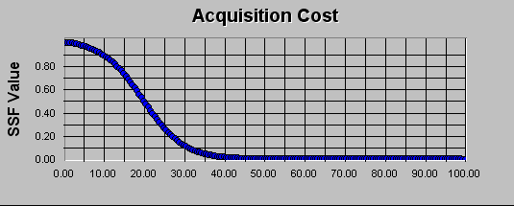

- Total Process Time:

Score: US3P1 = SSF (ULTH3P1, UB3P1, UUTH3P1, USL3P1)

Units | Hours
Lower Threshold | ULTH3P1 | 500
Baseline | UB3P1 | 2500
Upper Threshold | UUTH3P1 | 5000
Slope | USL3P1 | -0.0005

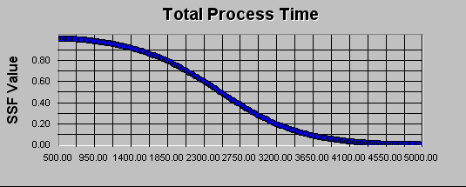

3.7.3. Utilization of resources tests

1. Acquisition Time: This will be measured by noting if each submission is submitted on time, and/or tallying the total points lost each day for late submission (10% a day, will be lost for late submission).

2. Acquisition Cost: This figure of merit is a summation of all the costs required to complete this project.

3. Total Process Time: The total process time will be calculated by summing the total time spent by each member in delivering each document.

3.5.3. Weighting Criteria

The importance value of each Utilization of Resources Criteria was gauged on a 1-10 scale (1 being the least important, 10 being the most). The weight for each criterion (UWiP0) was then calculated by taking its importance value and dividing it by the sum of the importance values for all criteria. (Note: The sum of the UWiP0 = 1).

 | Figure of Merit | Value | UWiP0
1 | Acquisition Time | 10 | 0.43478
2 | Acquisition Cost | 7 | 0.30435
3 | Total Process Time | 6 | 0.26087

3.6. Trade-Off Requirement

The Trade-Off Requirement (TF0P0) will be calculated as a weighted average of the Total I/O Performance Index and the Total Utilization of Resources Index. We define these variables and their associated weights with the following symbols and values:

Variable Name | Variable Symbol | Weight Symbol | Weight Value
Total I/O Performance Index | IFX0P0 | TW1P0 | 0.4
Total Utilization of Resources Index | UFX0P0 | TW2P0 | 0.6

Accordingly, the Trade-Off Requirement is calculated by the formula:

TF0P0 = (IFX0P0 * TW1P0) + (UFX0P0 * TW2P0)
= (IFX0P0 * 0.4) + (UFX0P0 * 0.6)

3.7. System Test Requirement

3.7.1. Test plan

3.7.1.1. Explanation of test plan
The system will be tested by Dr. Bahill, in various increments and then a final test of the system at the end of the course. Throughout the course of the semester, the team will submit documents as specified by the timeline provided by Dr. Bahill, and the entire system will be submitted for the final evaluation on Dec. 7th , 2005

System will be accepted if:

- Each individual document meets the necessary requirements as specified in Dr. Bahill’s “The Eight Systems Engineering Documents.”
- All the system documentation is submitted by December 7th, 2005.
- The solution provided in “The Eight Systems Engineering Documents” is a feasible solution.
- The solution has been approved by all of the team members.
- The solution can be delivered in accordance to the guidelines for submission set by Dr. Bahill.

3.7.1.2. Test Trajectory 1

Each team member will review the documents and they will give their approval to submit for the documents for grading.

3.7.1.3. Test Trajectory 2

The tools to submit the documents/assignments will be tested prior to submission.

3.7.1.4. Test Trajectory 3

The developed document will be compared with documents Dr. Bahill has previously provided as examples.

3.7.1.5. Test Trajectory 4

The copies of the document are presented in common readable format. The file must be in a .doc or .pdf format.

3.7.2. Input/output performance tests

1. Correctness: This will be measured against Dr. Bahill’s requirements as specified in Dr. Bahill’s “The Eight Systems Engineering Documents.”

2. Quality: This figure of merit will be calculated by Dr. Bahill, by comparing the work presented to past examples of work that has a high degree of excellence.

3. Thoroughness: This is computed by examining the level of detail and completeness provided in each of the documents.

4. Efficiency: This will be calculated by dividing the total time it took by all members to complete each submission, by the grade each submission receives. These numbers will be compared to the expectations Dr. Bahill believes is necessary to obtain a certain grade.

5. Clarity: This will be evaluated by how easy to understand and how clear each document is, and will be a judgment call based on Dr. Bahill’s experience as a professor.

3.7.3. Utilization of resources tests

1. Acquisition Time: This will be measured by noting if each submission is submitted on time, and/or tallying the total points lost each day for late submission (10% a day, will be lost for late submission).

2. Acquisition Cost: This figure of merit is a summation of all the costs required to complete this project.

3. Total Process Time: The total process time will be calculated by summing the total time spent by each member in delivering each document.

3.8. Rationale for operational need

The main purpose of developing this system is as a learning tool for students to become familiar with the principles behind Systems Engineering. A secondary purpose of developing this system is to give students the opportunity to work in groups, which will be similar to the real working environment upon graduation with an engineering degree.

4. Systems Engineering Document: Process Systems Requirements Validation

4.0. Configuration Management

Document Lead: RF
Assistant: MD

Date Version Team Members
10/25 0.1 RF
10/30 0.1 RF
11/9 1.0 MD,FD,DH,RF,SS

4.1. Input/Output Functional Design

After examining the required inputs and outputs for our system, previous SIE 554a students have been able to meet the input/output requirements of this system, so it is clear that this system is feasible.

4.2. Technology for the Buildable for the System

All of the techniques mentioned in our derived requirements document are currently in existence today and are considered very reliable technologies. Therefore, it does not seem that there will be any problems using these technologies to build our system.

4.3. Input/Output Performance Requirement

The input/out performance requirements are typical expectations of a system such as ours, and it is not foreseen that there will be any difficulty in meeting these requirements.

4.4. Cost Requirement

The cost requirements are very reasonable for this system. The amount of money budgeted for this system is quite minimal, especially considering that there are 5 members in the team to divide these costs between.

4.5. Schedule Requirement

The schedule requirement states that the system and all corresponding documents must be completed by December 7th, 2005. This timeframe is one semester long, and other prior students in SIE554a have already demonstrated that 1 semester is a sufficient timeframe to complete this system.

4.6. Test Requirement

No problems are foreseen in meeting the necessary requirements as specified in the derived requirements document. Dr. Bahill has graded many SIE554a projects in previous years, so there should be no problem using him as the means to determine if our system is acceptable.
5. Systems Engineering Document: Process Concept Exploration

5.0. Configuration Management

Document Lead: DH
Assistant: MD,SS

Date Version Team Members
9/20 0.1 DH
10/16 0.2 DH
10/18 0.3 DH
10/19 1.0 MD,FD,DH,RF,SS

5.1. Process Systems

Here we explore the process systems that we will use to generate the systems engineering documents.

5.1.1. System Design Concept 1 (Do Nothing)

In this concept we do nothing and all fail the class.

5.1.2. System Design Concept 2 (Pareto collaboration)

In this concept 20% of the team does 80% of the work in generating the various documents.

5.1.3. System Design Concept 3 (Egalitarian collaboration)

In this concept each teammate contributes 20% of the work to each document and the collaboration is shared equally among all team members.

5.1.4. System Design Concept 4 (Lie/Cheat/Steal)

In this concept we simply regurgitate documents from previous years, pay students to generate documents for us, and submit a sub-standard document set as our team goal.

5.2. Evaluation Criteria

In order to be fair and impartial to each concept we selected Input/Output and Utilization of Resources requirements.

5.2.1. I/O Requirements

Correctness – how correct are we (higher is better)
Quality – what level of quality are we at (higher is better)
Thoroughness – how thorough are we (higher is better)
Efficiency – how efficient are we (higher is better)
Clarity – how clear are we (higher is better)

5.2.2. U/R Requirements

Acquisition Time – How fast can acquire documents (faster is better)
Acquisition Cost – How cheap can we acquire documents (faster is better)
Total Process Time – How fast can we complete the document set (faster is better)

5.3. Analytical Hierarchy Process
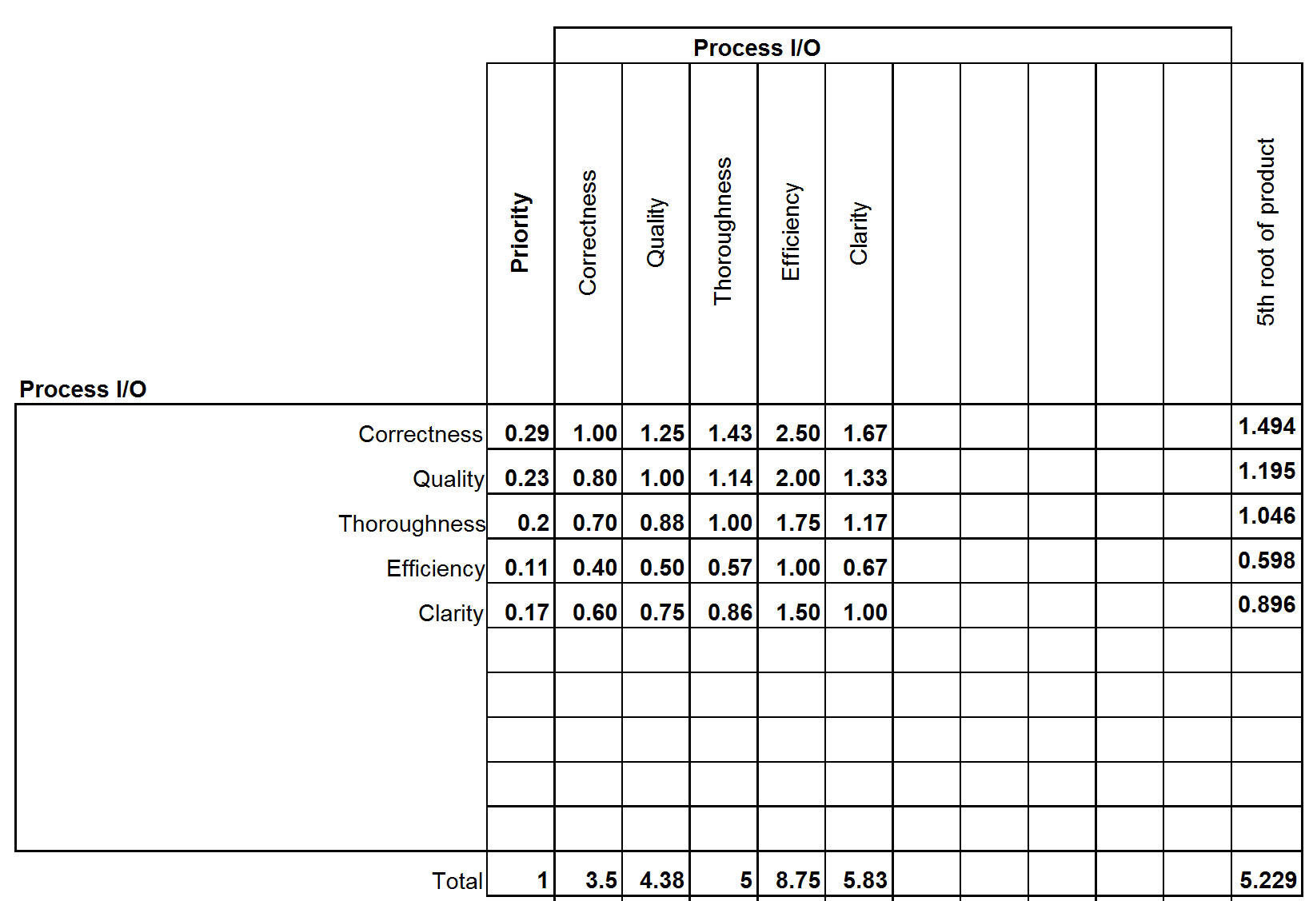

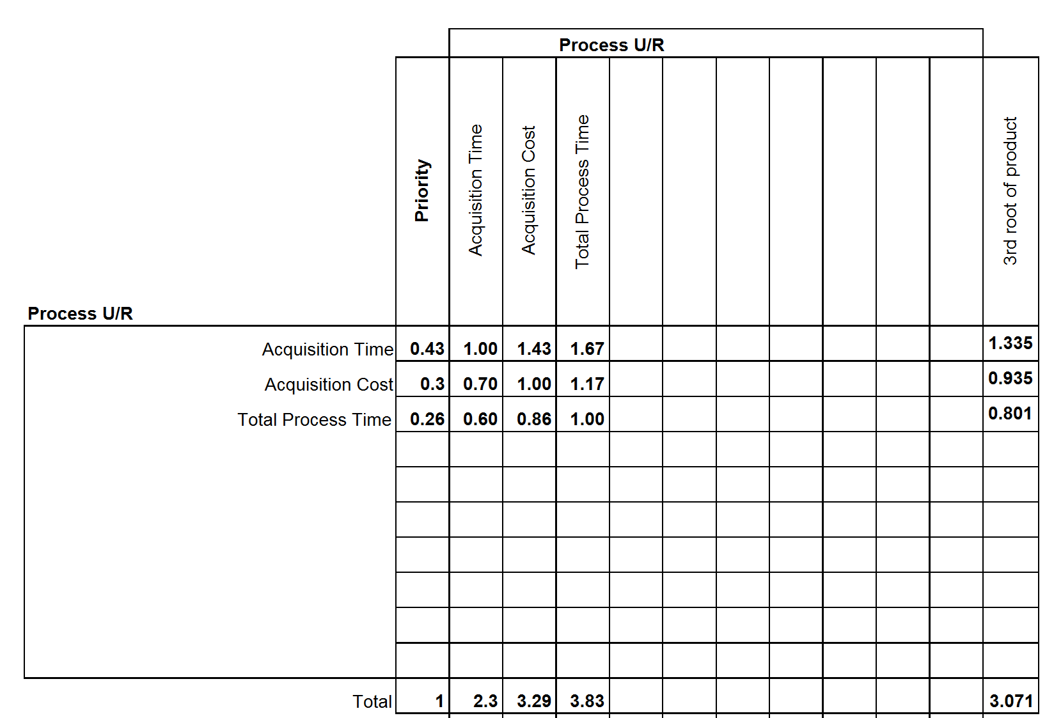

5.3.1. Trade-off Matrix

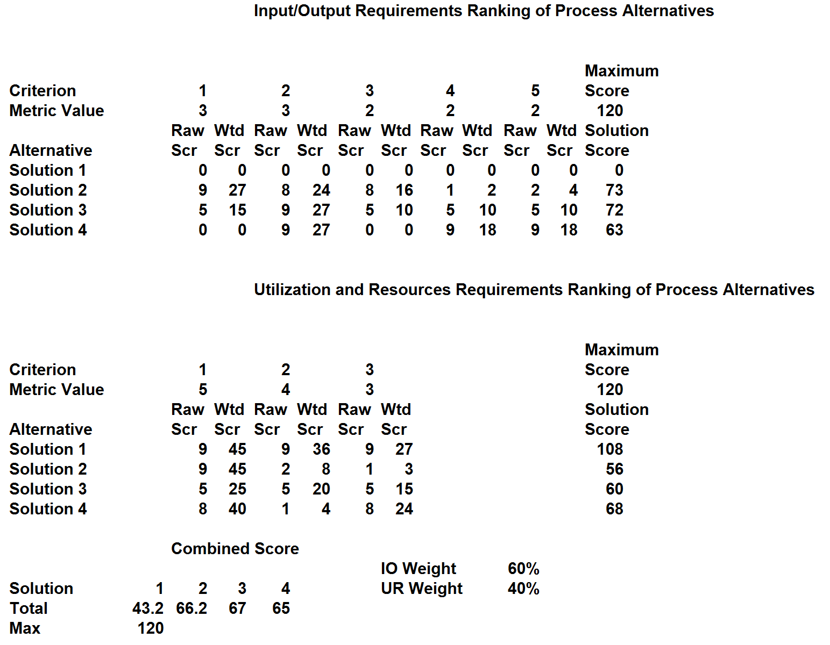

5.3.2. Sensitivity Analysis

Further sensitivity analysis may reveal weaknesses in this model.

5.4. Recommended Alternatives

Based on the trade-off study and analytical hierarchy process we see that Process Concept 3 (Egalitarian Collaboration) is the winner. This means that we should equally contribute to the generation of all the documents.

5.5. Cognitive Bias

The only cognitive bias would be that team members refuse to contribute equally.

6. Systems Engineering Document: Process Use Case Model

6.0. Configuration Management

Document Lead: SS
Assistant: DH

Date Version Team Members
9/20 0.1 DH,SS
9/21 0.2 DH,RF,SS
9/24 0.3 RF
9/24 0.4 FD
9/26 1.0 MD,FD,DH,RF,SS

6.2. Use Case Model: Process

This will contain high and low level diagrams of the use case reports representing the system.

6.2.1. High Level

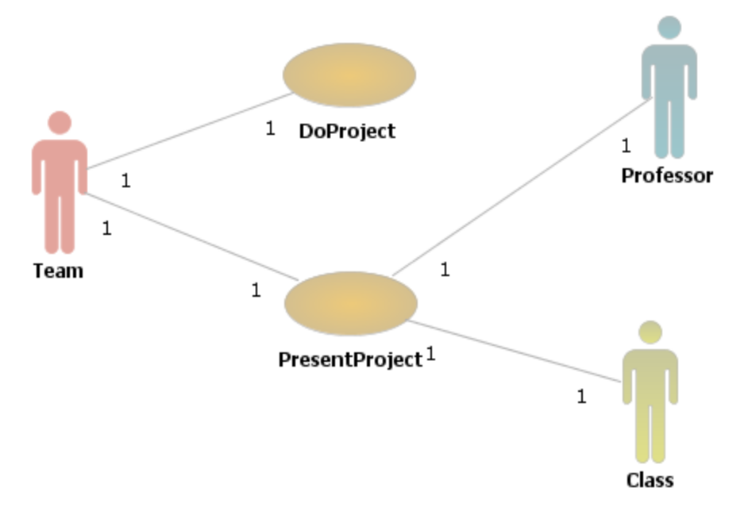

6.2.2. Low Level

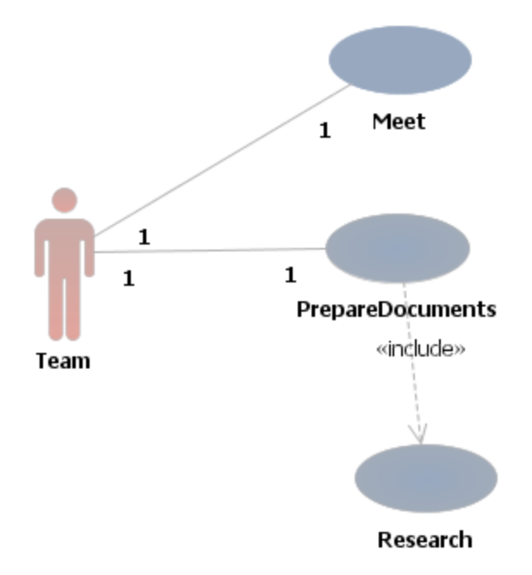
6.3. Use Case Report

6.3.1. High Level Use Cases

Name: Do Project
Level: High
Description: This use case describes a top-level overview of how the team does the project.
Scope: SIE554a Class at the University of Arizona
Actors: Team
Preconditions: Team is registered for SIE554a
Main Success Scenario:
- Team meets
- Team researches
- Team prepares documents
Post-Conditions: The team has successfully completed the required SIE554a project.
Author: Rhea Frondozo, Version 1, 24 Sep 05

Name: Present Project
Level: High
Description: This use case describes a top-level overview of how the team will present the project to the class
Scope: SIE554a Class at the University of Arizona
Actors: Team, Professor, Class
Preconditions: Team is registered for SIE554a; team has done the project.
Main Success Scenario:
1. Team does project
2. Team prepares presentation
3. Team goes to class to present
Post-Conditions: After completion of the SIE554a project, the team will have presented the project to the class and professor.
Author: Rhea Frondozo, Version 1, 24 Sep 05

6.3.2. Low Level Use Cases

Name: Meet
Level: Low
Description: This use case describes methods the team uses to meet.
Scope: Team enrolled in SIE554a Class
Actors: Team
Preconditions: Team has been formed for SIE554a Class
Main Success Scenario:
- Team decides what to meet for
- Team decides medium for meeting
- Team decides when to meet
- Team shows up for meeting
- Team discusses requirements for homework assignments
- Team brainstorms solutions
- Team designates individuals to be responsible for various portions of the homework assignment
Post-Conditions: Team will leave the meeting in understanding of who is responsible for what portions of the homework.
Author: Rhea Frondozo, Version 1, 24 Sep 05

Name: Prepare documents
Level: Low
Description: This use case describes a top-level overview of how the team does the project.
Scope: SIE554a Class at the University of Arizona
Actors: Team
Preconditions: Team is registered for SIE554a
Main Success Scenario:
- Team meets
- Team does research
- Team prepares documents
Post-Conditions: The team will have completed documents that meet the necessary requirements.
Author: Rhea Frondozo, Version 1, 24 Sep 05

Name: Research
Level: Low
Description: This use case describes the team uses find necessary information used in the documents.
Scope: Preparation of one document
Actors: Team
Preconditions: Team has determined topic to research.
Main Success Scenario:
- Team finds sources
- Team extracts relevant information from sources
Post-Conditions: The team will have relevant information relating to the document to be prepared.
Author: Rhea Frondozo, Version 1, 24 Sep 05

6.4. Use Case Requirements Specification

6.4.1. Specific Requirements

- Req. SR1: The team shall have Homework 1 completed by and turned in by August 29, 2005.
- Req. SR2: The team shall have Homework 2 completed by and turned in by September 7, 2005.
- Req. SR3: The team shall have Homework 3 completed by and turned in by September 14, 2005.
- Req. SR4: The team shall have Homework 4 completed by and turned in by September 21, 2005.
- Req. SR5: The team shall have Homework 5 completed by and turned in by September 28, 2005.
- Req. SR6: The team shall have Homework 6 completed by and turned in by October 5, 2005.
- Req. SR7: The team shall have Homework 7 completed by and turned in by October 10, 2005.
- Req. SR8: The team shall have Homework 8 completed by and turned in by October 11, 2005.
- Req. SR9: The team shall have Homework 9 completed by and turned in by November 9, 2005.
- Req. SR10: The team shall have Homework 10 completed by and turned in by November 21, 2005.
- Req. SR11: The team shall have Homework 12 completed by and turned in by December 5, 2005.
- Req. SR12: The team shall have Project Document 1 & 8 completed and turned in by September 12, 2005.
- Req. SR13: The team shall have Project Document 5 completed and turned in by September 19, 2005.
- Req. SR14: The team shall have Project Document 6 completed and turned in by September 26, 2005.
- Req. SR15: The team shall have Project Document 2 completed and turned in by October 3, 2005.
- Req. SR16: The team shall have Project Document 3 & 5 completed and turned in by September 19, 2005.
- Req. SR17: The team shall have Lab Test completed and turned in by October 24, 2005 and October 26, 2005.
- Req. SR18: The team shall have Exam 1 completed and turned in by October 19, 2005.
- Req. SR19: The team shall have Final Exam completed and turned in by December 9, 2005.

6.4.2. Functional Requirements

- Req. FR1: The team shall turn in the project as two different sets of documents.
- Req. FR2: The team shall use a conference call to present the project.
- Req. FR3: The team shall use an overhead projector to present the project.
- Req. FR4: The team shall use a weekly conference call to communicate homework comments and concerns.
- Req. FR5: The team shall use multimedia to present the project to the class.

6.4.3. Nonfunctional Requirements

- Req. NFR1: The team for the class project shall create a set of documents describing the product two days before the document is due.
- Req. NFR2: The team for the class project shall create a set of documents describing the process two days before the document is due.
- Req. NFR3: The team shall keep the costs of the class within $100 for each student.
- Req. NFR4: The team member shall keep notes of each class.
- Req. NFR5: The team member shall attend every class during the semester.
- Req. NFR6: The team shall have one team member compile all project documents and homework before they are submitted to Dr. Bahill.
- Req. NFR7: The team shall transfer documents between team members via email.

6.4.4. Supplementary / System Wide Requirements Specification

- Req. SRS1: The team shall use Microsoft Office PowerPoint to present the project.
- Req. SRS2: The team members shall have telephones that allow 3-way calling.
- Req. SRS3: The team shall discuss the documents before submitting the results to Dr. Bahill.
- Req. SRS4: The team shall inform other team members of assignments that will not be submitted on time.
- Req. SRS5: The individual team members shall inform other team members of the possibility of missing a team meeting.

7. Systems Engineering Document: Process Design Model

7.0. Configuration Management

Document Lead: SS
Assistant: DH

Date Version Team Members
11/3 0.1 MD,DH,SS
11/7 0.2 MD,DH
11/9 1.0 MD,FD,DH,RF,SS

7.1. System interfaces

The system interfaces will be designed based on the application of concept exploration onto the customer requirements based upon the object model of Document 6. Operator notifications are designed into the system in order to provide feedback.

7.2. Design model

The design model is the product of the requirements model and the analysis model and will eventually evolve into the implementation model, the testing model, and finally the operational model.
7.2.1. Class diagram

This class diagram shows the main classes involved in our top level system function:

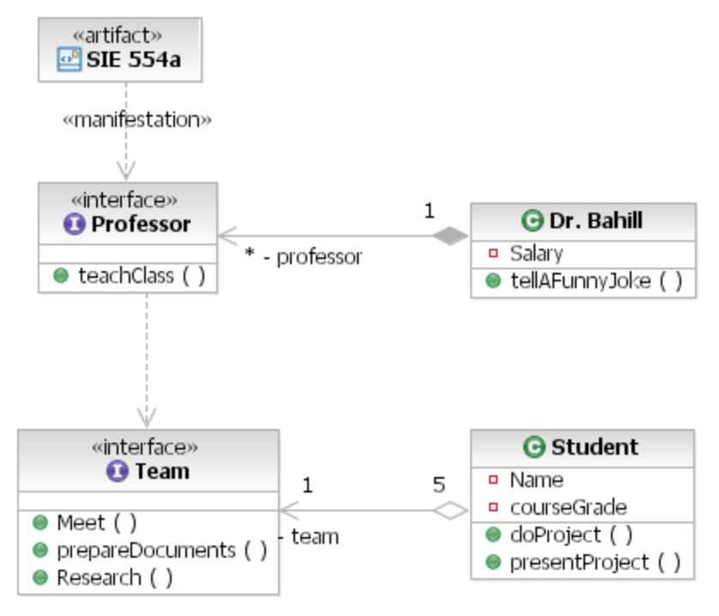
7.2.2. Communication diagrams

Returns from calls are not shown on the communication diagrams. See the sequence diagrams for return information.

7.2.2.1. Communication diagram for Do Project use case
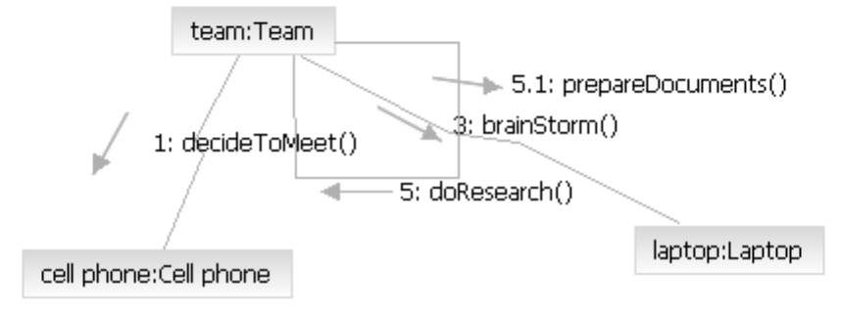
7.2.3. Sequence diagrams

7.2.3.1. Sequence diagram for Do Project use case
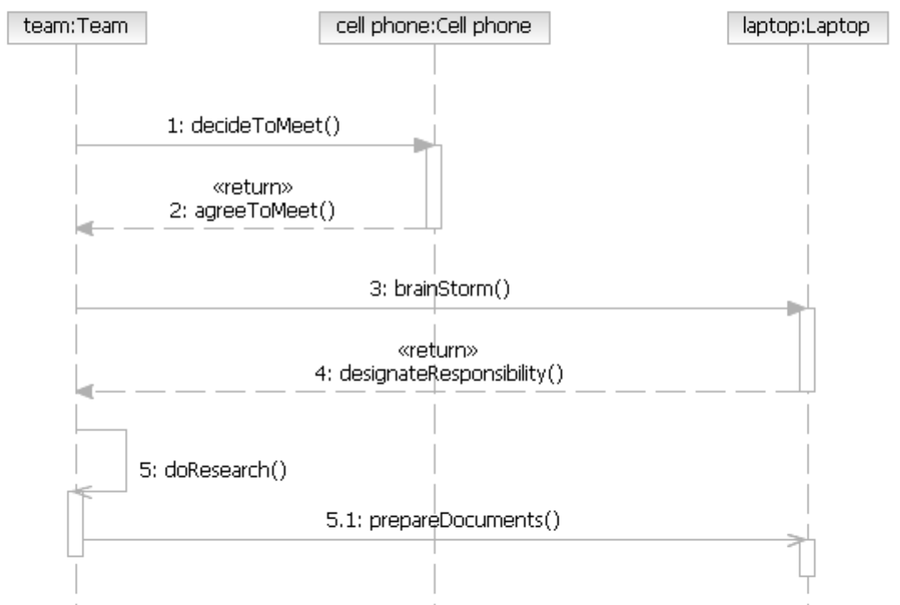
7.2.3.2. Sequence diagram for Present Project use case
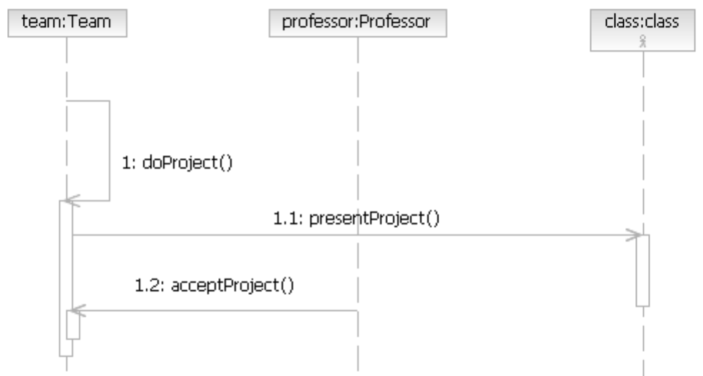

7.2.4. Component diagram
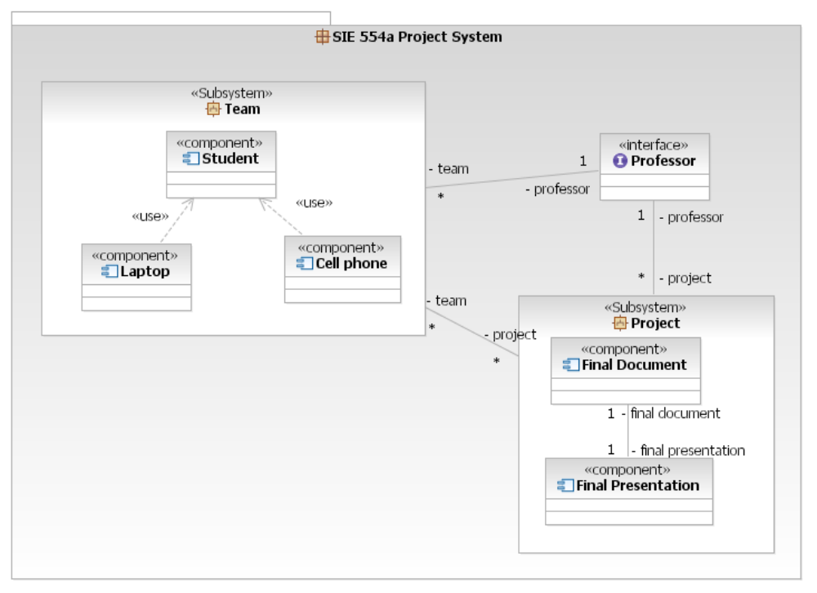
7.2.5. Deployment diagram

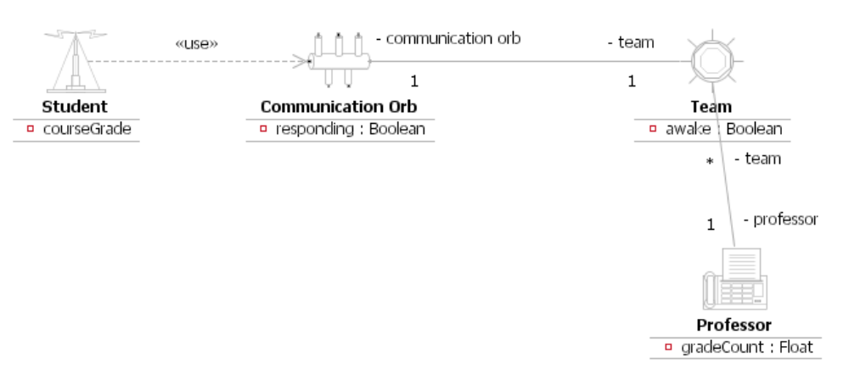

7.3. Implementation model

The implementation model is our final cut at the system which will be validated into the testing model.

7.4. Operational model

The operational model is the actual production system after the testing model has been validated to ensure all customer requirements are met.

8. Systems Engineering Document 8: Models, Mapping and Management

8.0. Configuration Management

Document Lead: DH
Assistant: SS

Date Version Team Members
9/8 0.1 DH,SS
9/9 0.2 DH,SS
9/12 1.0 MD,FD,DH,RF,SS
9/20 1.1 MD

8.1. Document Structure

This document shows how the requirements, verification plan, evaluation criteria, use case and object models map to each other.

8.2. Document Mappings

8.2.1. Process Mappings

The document mapping table shows in what order our team will be writing these documents in relation to each other.

Requirements | Document 2  Customer Requirements | Document 3  Derived Requirements | Document 5  Concept Exploration | Document 6  Use Case Model | Document 7  Design Model
Input/ Output and Functional Requirements | 2.2 | 3.2 | 5.2 | 6.4 | 7.1
Technology Requirements | 2.3 | 3.3 | 5.3 | 6.4 | 7.1
Input/ Output Performance Requirements | 2.4 | 3.4 | 5.4 | 6.4 | 7.1
Utilization and Resources Requirements | 2.5 | 3.5 | 5.5 | 6.4 | 7.1
Trade Off Requirements | 2.6 | 3.6 | 5.6 | 6.4 | 7.1
System Test Requirements | 2.7 | 3.7 | 5.7 | 6.4 | 7.1
Rational Operational Need | 2.8 | 3.8 | 5.8 | 6.4 | 7.1

The above table illustrates that documents 2 through 7 each has seven different requirement sections (Input/Output and Functional, Technology, etc.) that is found within each document.

8.3. Activity Diagrams

8.3.1. Process Activity Diagrams

The following subproject Activity Diagram shows how each workflow progresses from beginning to termination.
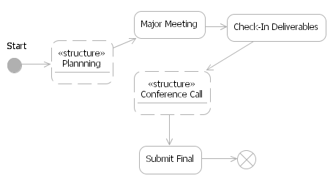
8.4. User Manual

The process User Manual is attached in Appendix B.

8.5. Risk Analysis

8.5.1. Quantitative Risk List

Scenario | Probability of occurrence (one semester) | Severity (in dollars $1-$10000) | Risk (cost of failure in dollars)
Project not completed on time | 0.01 | 1000 | 10
Project does not receive passing grade | 1 | 1000 | 100
Project not completed at all | 0.001 | 3000 | 3

8.5.2. Qualitative Risk List

Priority | Risks | Possible Consequence | Risk Level | Response
1 | Time scheduling | Uncoordinated team movements | Very High | Coordinate and maximize process time
2 | Cultural or language barrier | Miscommunication or non-communication between team | High | Establish trust and boundaries
3 | Software tools incompatible | Duplication of effort | Medium | Agree on interoperable tools, fonts, etc.
4 | Iteration slippage | Fail assignment | Medium | Frequent delivery
5 | Student misappropriation of resources | Fail class | Low | Close communication between team members

8.6. Schedule

8.6.1. Gantt chart and Network Activity Diagram

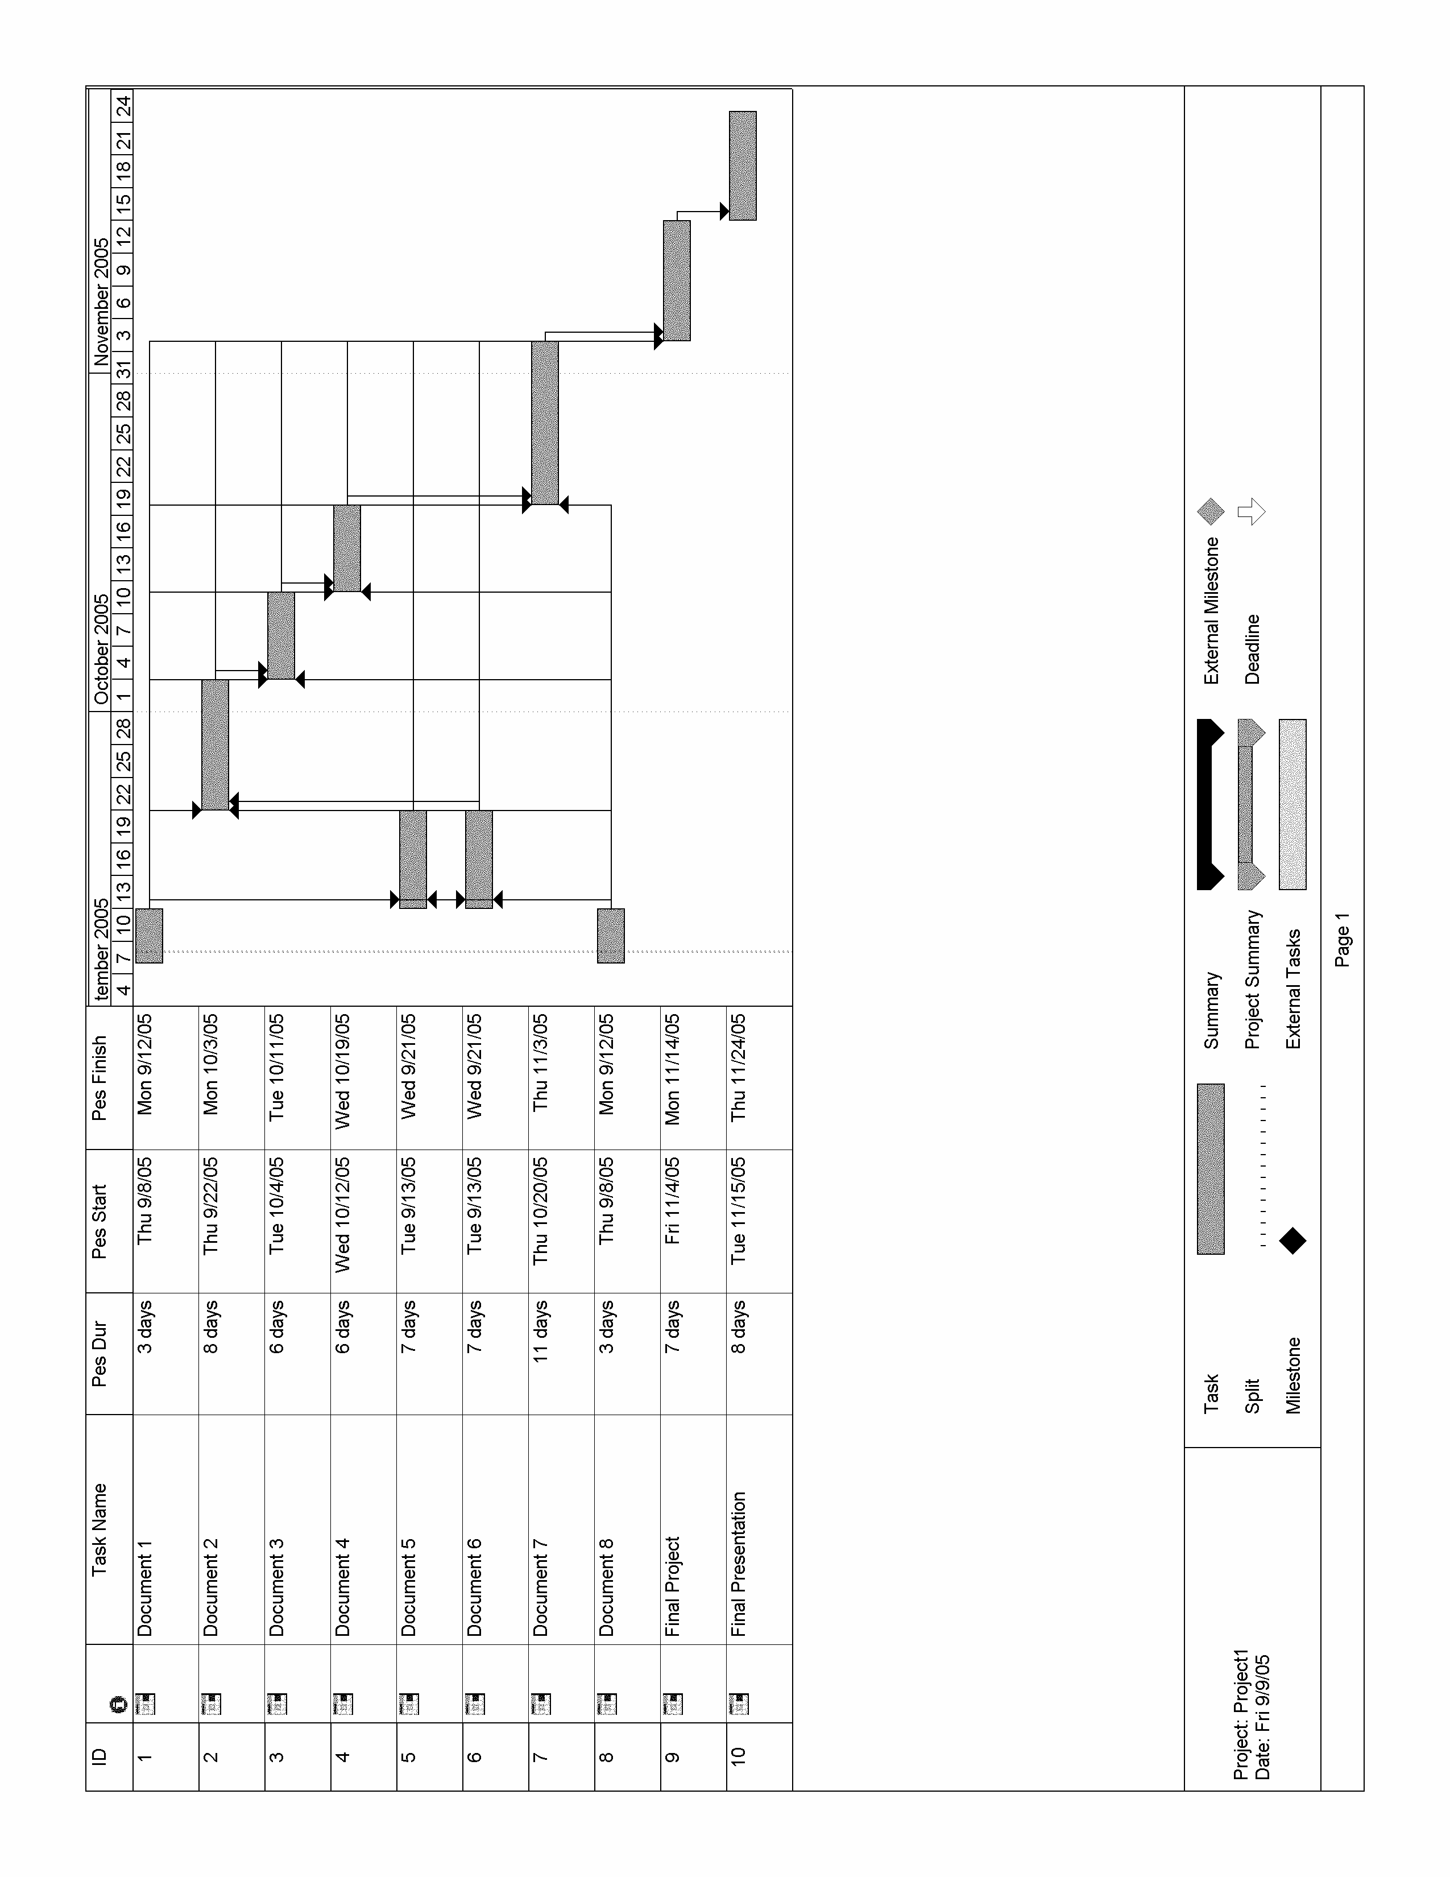
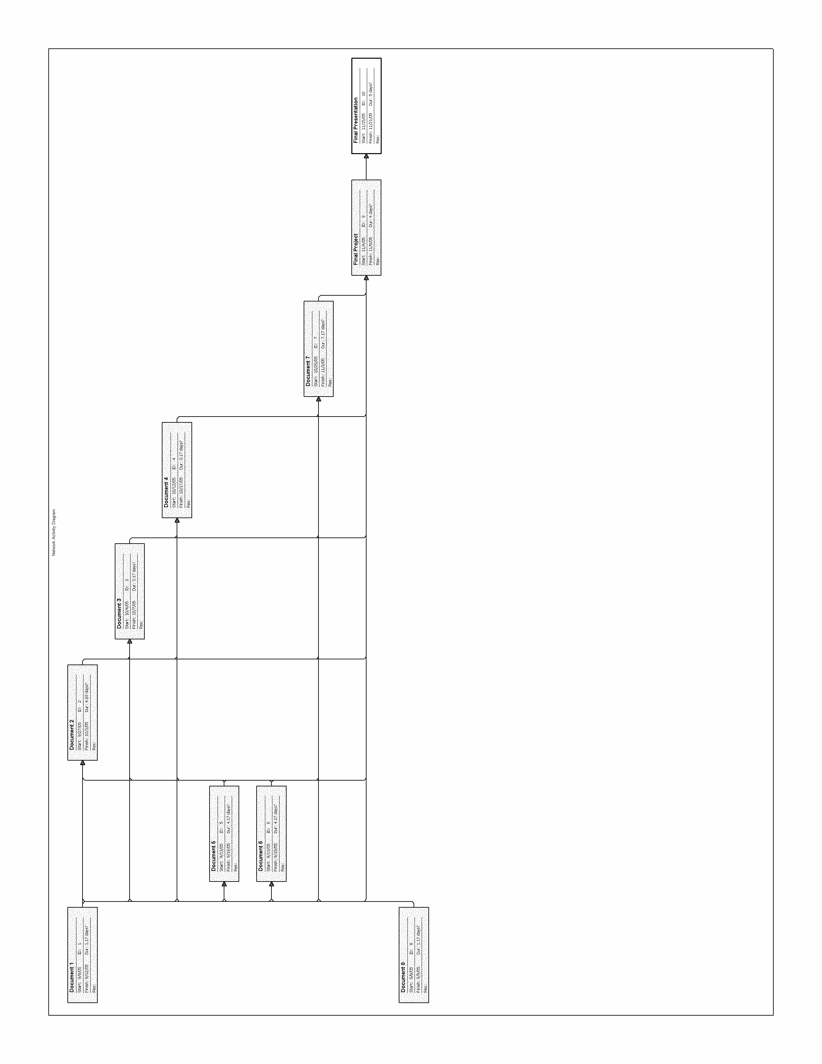
8.6.2. Process Burn-Up Charts

The following chart delineates the overall project completion flow with mandatory deadlines.

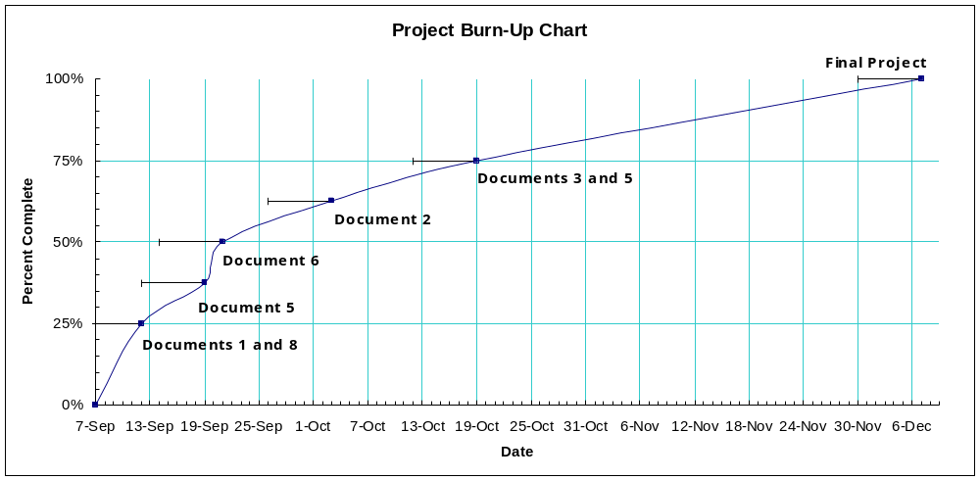

The next eight charts show the breakdown of subproject iterations and deliverables. Based on the mandatory milestones we devised a schedule which spread the work out evenly over each subproject’s iteration.

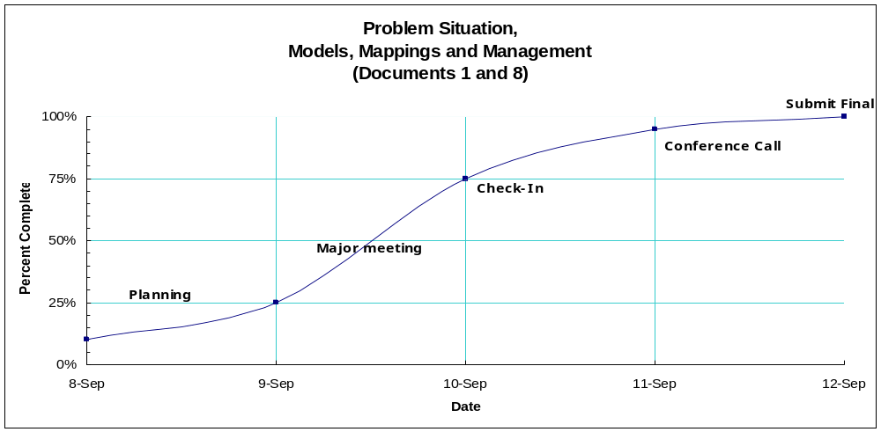

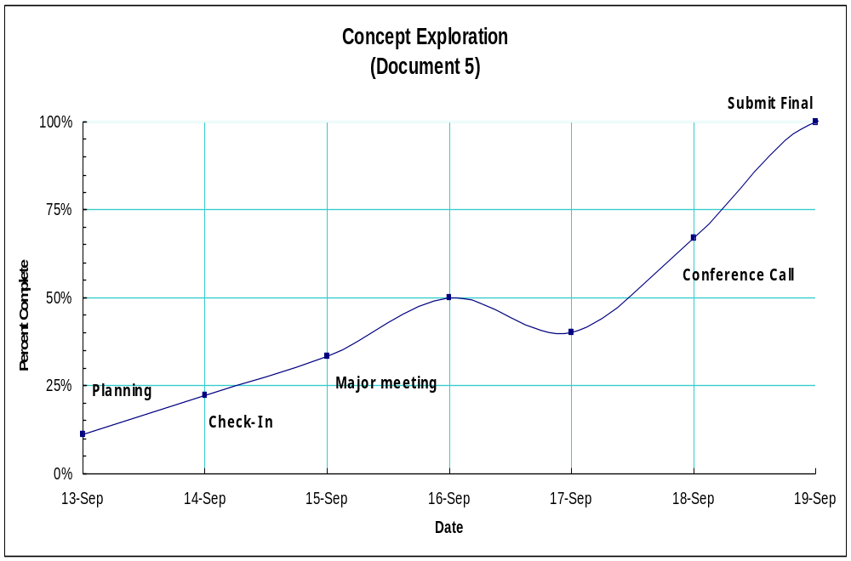

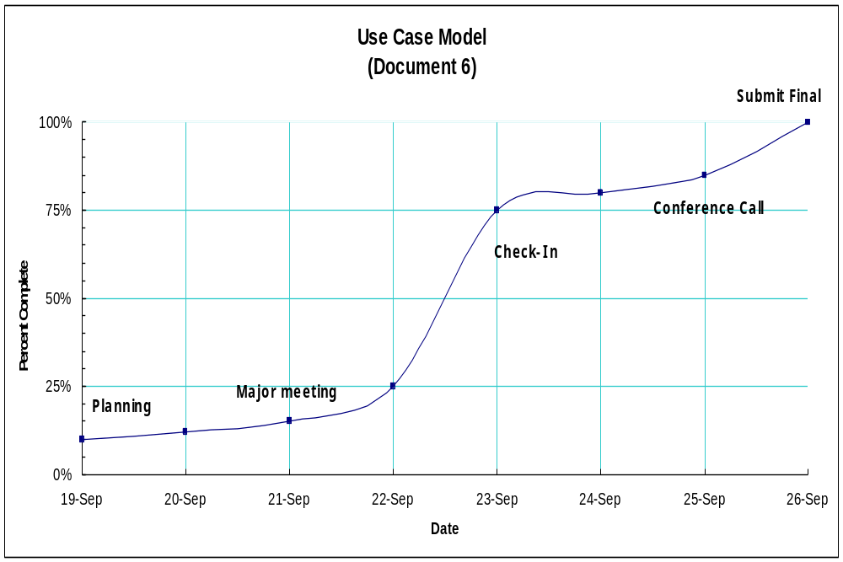
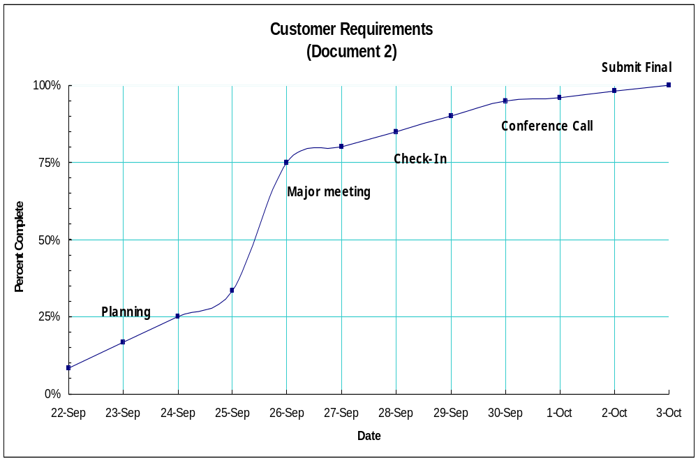

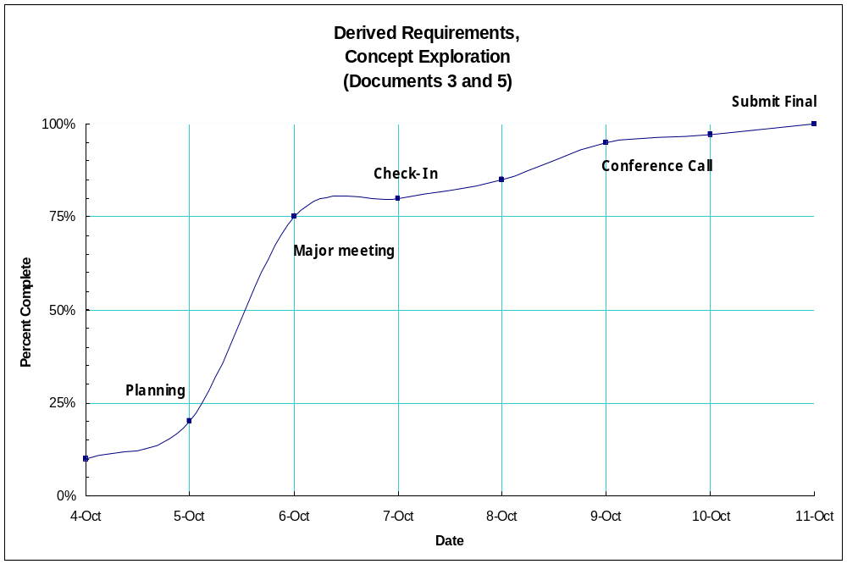

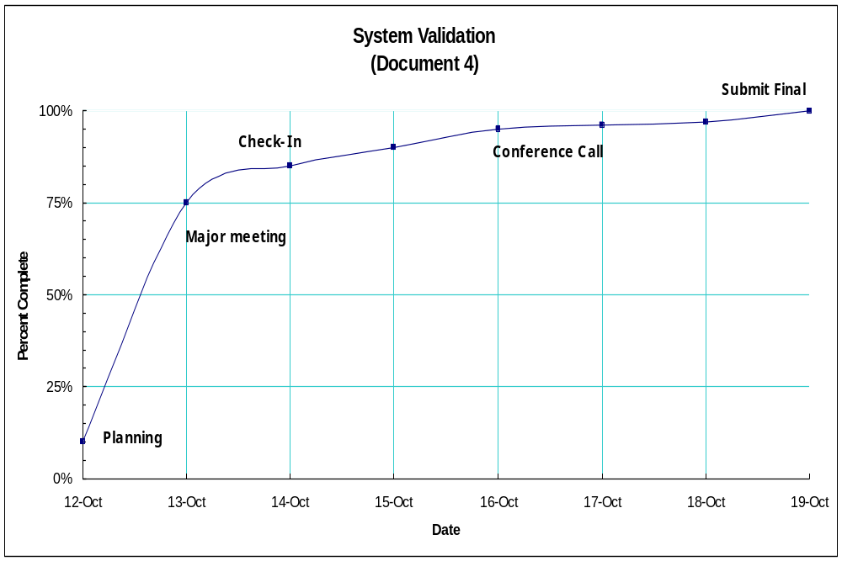

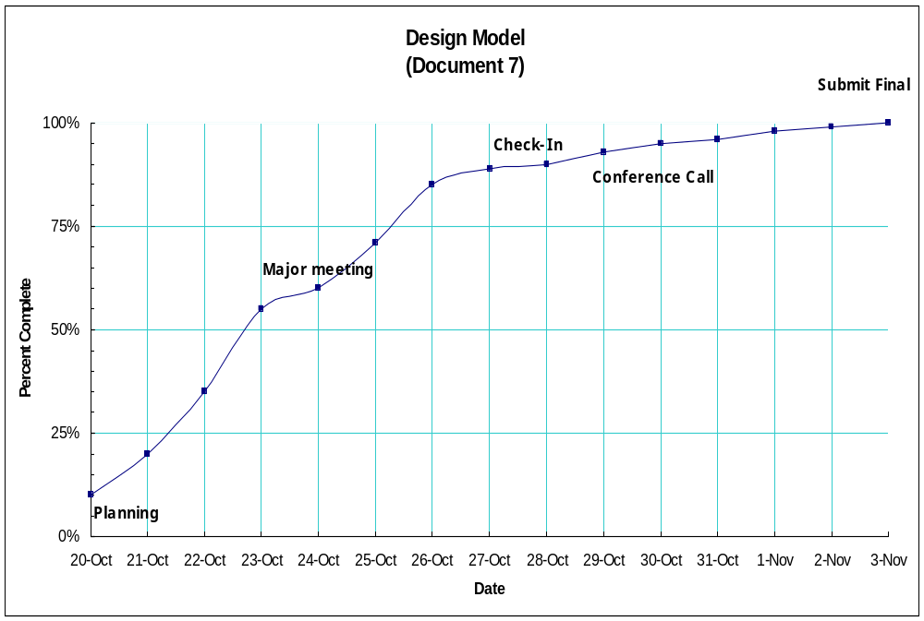

Scheduling a subproject for the final iteration of the project and also the presentation allows us ample leeway in discerning temporal shifts in iteration efficiency.

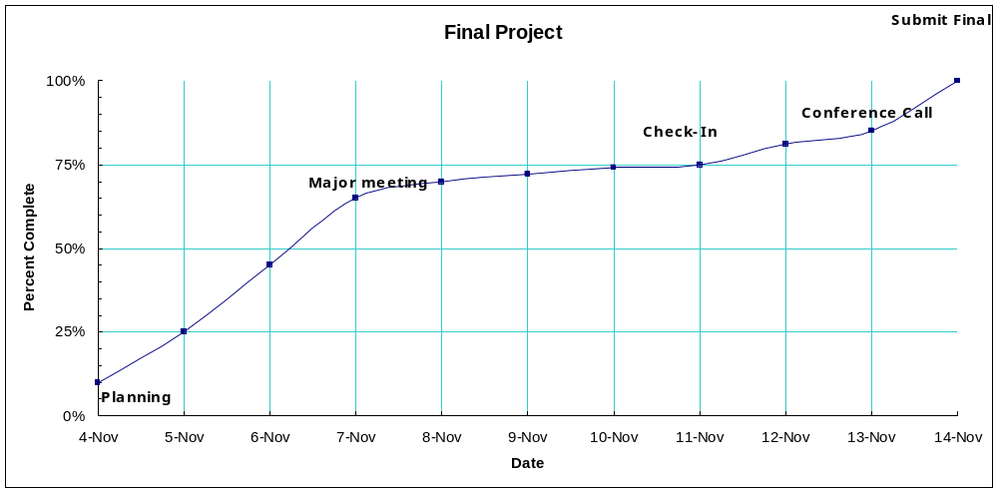

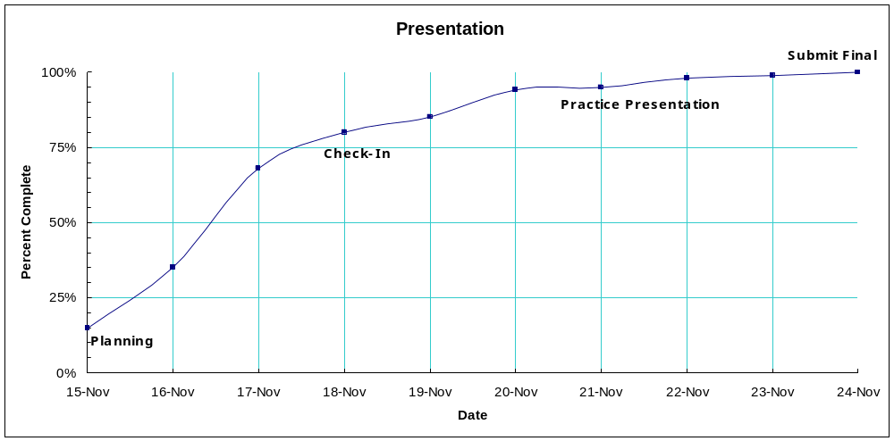

8.7. Project Work Breakdown Structure

We agreed on a work breakdown dynamic of selecting official group members to various tasks and rotating roles as to foster a cohesive group communications strategy. Thus far, we have delegated the work as follows:

Roles and Responsibilities:

1. Each of the 8 Documents will have a Leader and an Assistant, namely:

Document # | Leader | Assistant
1 | Matt | Rhea
2 | Rhea | Matt
3 | Matt | Rhea
4 | Rhea | Matt
5 | David | Matt / Shahan
6 | Shahan | David
7 | Shahan | David
8 | David | Shahan

- The Document Leader is responsible for understanding the purpose of the document, its components, and format. As a guide, the Document Leader should have several examples of a successful Document X and understand the approximate length / detail of the contents.
- The Document Leader will assign individual responsibilities for completing the document on time, as well as recommending meeting times / locations for its development and completion.
- The Document Leader should expect to make multiple revisions to Document X during the course of the semester; as the design evolves so should his Document.
- Any revisions / changes to Document X, should be sent immediately to all group members IOT create multiple “back-up” copies.

2. Matt will serve as the Group Leader. In this capacity he will track suspenses, monitor quality, ensure the equitable distribution of work, and provide liaison with Professor Bahill. Additionally, he will perform any administrative tasks and ensure the group stays well informed.

3. Fabian will serve as the sole compiler. In this capacity, he will gather, proofread, and polish all submissions to a professional standard, indicative of the group’s hard work. Moreover, Fabian should expect to receive at least one homework problem per week to lighten the load on the Document Teams.

Appendix A: Glossary of Terms

Process Document – document used to separate all process knowledge from the product knowledge contained.

Time-to-Turn-In Basis - the date set by the professor to complete and hand-in the assignment.

Student Whims – the approach used by the student to understand the problem and develop a solution to the problem.

Student’s Leisure – the mode of thinking that will be used by the student to develop a possible solution to the problem.

Time-to-Completion – the amount of time required to successfully complete the class projects and homework by the due date.

Students - Matthew Dabkowski, Fabian Duarte, Rhea Frondozo, David Haas, Shahan Sikander

Final Test – the cumulative examination given on the final day of the semester, which will be used as the assessment measure for the students learning.

Documents – the SIE 554a class project with is broken down into eight separate documents.

Document 1 - problem situation section of the class project.

Document 2 - operational need/customer requirements section of the class project.

Document 3 - system requirements/derived requirements section of the class project.

Document 4 - system validation section of the class project.

Document 5 - concept exploration section of the class project.

Document 6 - functional decomposition/use case model section of the class project.

Document 7 - physical synthesis/design model section of the class project.

Document 8 - models, mappings and management section of the class project.
Appendix B: Process User Manual

Table of contents

Preface
1. Introduction to SIE-454a/554a
2. Motivation
3. Course Structure
4. Finding Solutions
5. Problem Solving
6. Course materials and submission
7. User Interface

Preface

This user manual is intended for students enrolled in SIE-454a/554a.

1. Introduction to SIE-454a/554a

The subtitle of this course is “Systems Engineering Process,” and as such is intended for graduating seniors and graduate students. The purpose of the course is to further develop the core technical documentation skill set needed to be successful systems engineers in the workforce and/or in continuing education.

2. Motivation

Motivation is the key to success in this course, because while the subject material may be overly-simplistic in some cases the underlying premise is not. Industry in both the public and private sector expects a rock-solid ability of the systems engineer to document and validate each system from conception to retirement. Success in this course means that the student has proved ability and fundamental understanding of the systems engineering process.

3. Course Structure

The structure of this course changes from year to year, however the basic structure does not. Students are required to not only submit homework and pass exams, but to develop an intensive series of systems engineering documentation for an arbitrary product and its associated process.

4. Finding Solutions

While GoogleTM is the modern day student’s lifeline and the scourge of professors everywhere, the best resource for students is the professors and teaching assistants themselves. These provide a valuable ecosystem of previous and concurrent knowledge and while not on-demand can sometimes deliver more expedient results. Even asking fellow classmates can procure valid feedback. The point being is that in order to find solutions sometimes you have to ask questions.

5. Problem Solving

The wrong way to solve problems is to shoehorn preconceived solutions into development before actually understanding the problem completely. The “code first, ask questions later” approach is in widespread deployment and is responsible for huge maintenance efforts and project collapses.

6. Course materials and submission

Course material is available online or students may purchase information packets. Homework and project documentation is submitted in hard-copy format, and exams must be proctored.

7. User Interface

The user interface for this course is two-fold; a traditional classroom setting and an internet/TV simulcast. Students may either attend class or watch it at their convenience. Teams must be formed in which students ideally collaborate with both on- and off-campus team members.

