Ancient Mysteries: Portolan Charts
Term: Fall 2019
About the Leader: A. Terry Bahill is Professor Emeritus of Systems Engineering and of Biomedical Engineering at the University of Arizona, (520) 742-5469, terry@sie.arizona.edu, http://www.sie.arizona.edu/sysengr/
Location: OLLI campus, 4485 N. First Ave, Ocotillo room
We need the Ocotillo room because we will use the big map on the wall.
Dates: Four sessions
September 16 to October 7, 2019 (Mondays, 1:30 – 3:30 pm)
Brief description:
Some things that were made in the 14th, 15th and 16th centuries are still not understood. These include ancient maps, portolan charts and Khipus made by the Inkas. Portolan charts are very detailed charts of the coast of the Mediterranean Sea. Who, Venetian and Majorcan chart makers. What, nautical charts. When, 1300 to 1550 AD. Where, the Mediterranean Sea. Why, to aid navigation. How, pen and ink on vellum integrating several smaller charts. You may read the first 15 pages of Campbell (1987) before class. You may download it and my slides from http://www.sie.arizona.edu/sysengr/OLLI/PortolanCharts/

Biographical Sketch
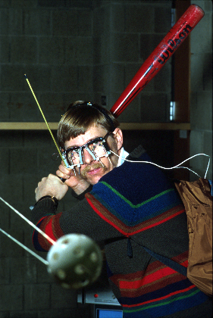Terry Bahill is Professor Emeritus of Systems and Industrial Engineering at the University of Arizona in Tucson. He received his Ph.D. in electrical engineering and computer science from the University of California, Berkeley, in 1975. He is the author of six engineering books and 250 scientific papers; over 100 of these are in peer-reviewed scientific journals. Bahill has worked with dozens of technical companies presenting seminars on Systems Engineering, working on system development teams and helping them to describe their Systems Engineering processes. He holds a U.S. patent for the Bat Chooser™, a system that computes the Ideal Bat Weight™ for individual baseball and softball batters. He was elected to the Omega Alpha Association, the systems engineering honor society. He received the Sandia National Laboratories Gold President's Quality Award. He is an elected Fellow of the Institute of Electrical and Electronics Engineers (IEEE), of Raytheon Missile Systems, of the International Council on Systems Engineering (INCOSE) and of the American Association for the Advancement of Science (AAAS). He is the Founding Chair Emeritus of the INCOSE Fellows Committee. His picture is in the Baseball Hall of Fame's exhibition "Baseball as America." You can view this picture at http://www.sie.arizona.edu/sysengr/. His research interests are in the fields of system design, modeling physiological systems, eye-hand-head coordination, human decision making, and systems engineering application and theory. He has tried to make the public appreciate engineering research by applying his scientific findings to the sport of baseball.

The following are just private notes for me.
Good, Bad and Ugly
video clips from the whole movie
https://www.youtube.com/watch?v=h1PfrmCGFnk
Danish orchestra
https://youtu.be/KkM71JPHfjk

An analog computer
So if you want the square root of d,
then hold a rock d feet above the ground.
Drop it and time how long it takes to hit the ground in seconds.
That is the square root of d.

My big paper charts are LibCong1500, Teixeira1600 and Teixeira1600
Before class began, I e-mailed to the students
Aguiar1492smallest
Teixeria1600BigMedium
Beccarii1403Replica
GoosInBook1667
GasparLiberRiveriumFig6VisibleLand
Seale1745

College of Engineering help desk
https://account.engr.arizona.edu
support@engr.arizona.edu
[#56158]
[#56157]
When I add a new file or directory, the system does not recognize it until you do something.

