Life in Thirds
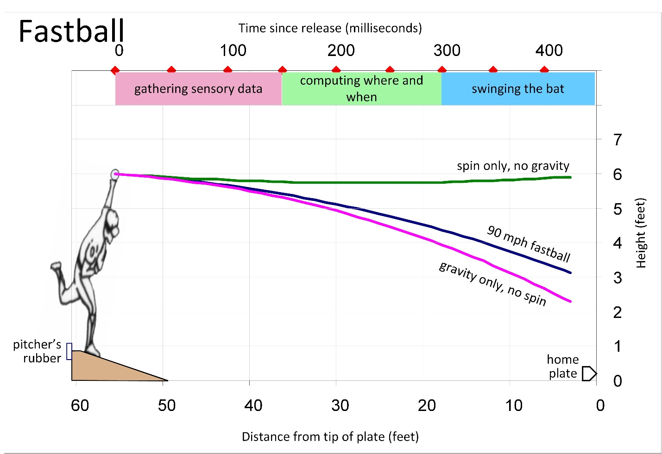
What the batter is doing during the pitch

First third, 0 to 150 ms, gathering sensory data
angular size of the ball,
rate of change of angular size,
angular distance of the ball's image off of the fovea,
ball’s retinal velocity,
binocular disparity,
apparent size,
retinal speed,
angle of pitching arm,
release point,
launch angle,
position of the fingers (the grip),
spin rate,
spin axis,
Second third, 150 to 300 ms, computing when and where the ball will be at the point of bat-ball collision
Estimating pitch speed, ball spin rate, time since release, and time until bat-ball contact.

Third third, 300 to 450 ms, swinging the bat,
If the batter closed his eyes during the swing, it would not affect the flight of the batted-ball.

Modeling Life
The Three Phases of Life
By A. Terry Bahill
Fall 2024
Life has three (or four) major phases: Taking, Producing, Giving, and the Sunset Years. The purpose of this paper is to tell seniors to get off their butts and go do something. The items listed in this paper ideally reflect things that are common for people in that particular age group and infrequent in other age groups, for example, most people raising children are in the 30 to 60 age group. Spoiling grandchildren is exclusive to the 60 to 80 age group.

First third of life, 0 to 30 years, Taking
Actions (verbs)
Go to school, take classes, develop body and brain, grow, learn, take from society, take in knowledge, play sports, drink, have sex, have fun, play, get tattoos, serve in the military, make mistakes, play video games, refuse advice, hold crazy political beliefs,
Conditions (nouns): honeymoon,
Why do girls put on makeup and style their hair? Because they are competing for a man to provide them with companionship, and physical and financial security.

Second third of life, 30 to 60 years, Producing
Actions
Create and raise children, work, promote self, family, community, society, nation, and environment.
If not working then following your passions,
Why do women put on makeup and style their hair? Out of habit, to impress other women and please themselves. Red lipstick helps others to read their lips.

Third third of life, 60-80 years, Giving Back/Returning,
Actions
Spoil grandchildren, travel, do volunteer work, tell stories, consult with industry, do hobbies, philanthropy, give advice, contribute wisdom through discussions and publishing papers and books, take pills, watch television, wake up in the night to pee,
Conditions:
retirement, not couch potatoes, frequent sickness, arthritis, cataract removal, caregivers, caretakers, grey or no hair
Why do women put on makeup and style their hair? Because if they are widows, they want to attract men. Otherwise, it may be to feel young.

The bonus years, 80-90 years, Sunset Years,
Actions
Slowing down, forgetting, physical and mental deterioration, dementia, care accepting, walking slowly, reading,
Conditions:
Thin skin, danger of infection, hearing aids, cataracts, frequent doctor visits, loneliness, risk of falls, short-term planning, no living parents, uncles, or aunts
Why do women put on makeup and style their hair? Just for the fun of it.

All three groups have friends, but those friends are different. For example, people in the 0-30 group go to a lot of weddings, whereas those in the 60 to 90 group go to a lot of funerals.

Kuan V, Denaxas S, Gonzalez-Izquierdo A, Direk K, Bhatti O, Husain S, Sutaria S, Hingorani M, Nitsch D, Parisinos CA, Lumbers RT, Mathur R, Sofat R, Casas JP, Wong ICK, Hemingway H, Hingorani AD. A chronological map of 308 physical and mental health conditions from 4 million individuals in the English National Health Service. Lancet Digit Health. 2019 May 20;1(2):e63-e77. doi: 10.1016/S2589-7500(19)30012-3. PMID: 31650125; PMCID: PMC6798263.

We developed case definitions for 308 disease phenotypes (ICD9s). We used records of 2 784 138 patients for the calculation of cumulative incidence and of 3 872 451 patients for the calculation of period prevalence and median age at diagnosis of these conditions. Conditions that first gained prominence at key stages of life were: atopic conditions (immune system) and infections that led to hospital admission in children (<10 years); acne and menstrual disorders in the teenage years (10–19 years); mental health conditions, obesity, and migraine in individuals aged 20–29 years; soft-tissue disorders and gastro-esophageal reflux disease in individuals aged 30–39 years; dyslipidemia (cholesterol), hypertension, and erectile dysfunction in individuals aged 40–59 years; cancer, osteoarthritis, benign prostatic hyperplasia, cataract, diverticular disease, type 2 diabetes, and deafness in individuals aged 60–79 years; and atrial fibrillation, dementia, acute and chronic kidney disease, heart failure, ischemic heart disease, anemia, and osteoporosis in individuals aged 80 years or older.
The cumulative incidence is the number of people in that age group in the study who had that condition divided by the total number of people in that age group that were in the study. To be in the study the person had to have been treated by their PCP or a hospital in England between 2010 and 2015, about 4 million people.

Condition | Incidence (%)
Age 0-9
Allergies | 5
Dermatitis | 8
Infections | 9
Asthma, eczema
Age 10-19
Acne | 10
Allergies | 4
Anxiety | 3
Depression | 3
Dysmenorrhea (menstrual cramps) | 5
Infections | 5
Menorrhagia (menstrual disorders) | 5
Age 20-29
Acne | 2
Anxiety | 4
Depression | 6
Dermatitis | 4
Infections | 6
mental health conditions, obesity, and migraine
Age 30-39
Anxiety | 4
Depression | 5
Dermatitis | 4
Enthesopathy(bone connectors) | 4
Gastro-esophageal reflux (GERD) | 3
Infections | 5
Menorrhagia  (menstrual disorders) | 6
Soft-tissue disorders
Age 40-49
Anxiety | 3
Depression | 5
Dermatitis | 4
High cholesterol | 6
Infections | 6
Erectile dysfunction
Age 50-59
Anxiety | 3
Cancer | 5
Depression | 4
Dermatitis | 4
Enthesopathy (connections bones) | 9
Erectile Disfunction | 6
GERD | 4
High cholesterol | 10
Hypertension | 9
Infections | 10
Osteoarthritis | 6
Age 60-69
Anxiety | 2
Benign prostatic hyperplasia | 6
Cancer | 10
Cataract | 5
Depression | 3
Dermatitis | 5
Diabetes | 4
Diverticular disease | 5
Enthesopathy | 9
Erectile Disfunction | 7
GERD | 4
High cholesterol | 12
Hypertension | 15
Infections | 25
Osteoarthritis, | 10
Age 70-79
Anemia | 11
Anxiety | 3
Atrial fibrillation | 17
Benign prostatic hyperplasia (prostate) | 10
Cancer | 19
Cataract | 14
Dementia | 5
Depression | 4
Dermatitis | 7
Enthesopathy | 7
Erectile Disfunction | 7
GERD | 5
Heart failure | 13
High cholesterol | 7
Hip fracture | 6
Hypertension | 21
Infections | 50
Kidney | 14
Myocardial infarction | 6
Osteoarthritis, | 12
Diverticular disease, diabetes, and deafness
Loneliness
Age 80+
Anemia | 11
Atrial fibrillation | 17
Cancer | 22
Cataract | 19
Dementia | 15
Dermatitis | 6
Enthesopathy | 5
GERD | 4
High cholesterol | 4
Hip fracture | 7
Hypertension | 24
Infections | 100
Myocardial infarction | 6
Osteoarthritis | 12
Stroke | 5
Urinary incontinence | 4
Kidney disease, heart failure, ischemic heart disease, anemia, and osteoporosis
Loneliness

Alcohol abuse (and other addictions) is about 3% from 10 to 60 years of age.
Loneliness is probably included in depression.

